IDPSIO v2.1.0

**Release notes**

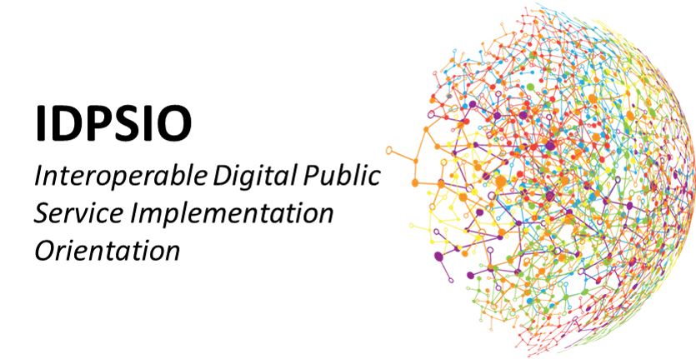

TABLE OF CONTENTS

1 Introduction 2

1.1 Purpose of this document 2

1.2 Release date 2

1.3 List of acronyms used in this document 2

2 Release components 3

2.1 IDPSIO V2.1.0 Herokuapp 3

2.2 Joinup 4

# Introduction

## Purpose of this document

This document contains the description of the release version 2.1.0 of the Interoperable Digital Public Services Implementation Orientation (IDPSIO)

## Release date

This version of the IDPSIO has been released on 09 of February 2023 in [Joinup.](https://joinup.ec.europa.eu/collection/european-interoperability-reference-architecture-eira/solution/egovera/release/v210)

## List of acronyms used in this document

Table 1-1

|  |  |
| --- | --- |
|  |  |
| IDPSIO | Interoperable Digital Public Services Implementation Orientation |
| PO | Project Officer |

# Release components

IDPSIO consists of the following release components

## IDPSIO V2.1.0 Herokuapp

IDPSIO consists of the following release components The IDPSIO (Interoperable Digital Public Services Implementation Orientation) Assessment Tool aims to supports digital public service owners in deciding the approach to follow in order to implement their digital public services. The IDPSIO model has been developed to support the Member States in understanding the implementation impacts from different angles: integration, technology, governance, and legal.

| Modification | Details |
| --- | --- |
| Version 2.1.0 | |
| Questions were updated | The content of the questions in the survey are updated and rephrased according to the detailed PO review |
| Copyrights were updated | The copyrights of the survey have been updated |
| Product license was added | The ISA product license (v1.4) has been included in the side menu as a hyperlink |
| Overall explanations added | The information is now clearer, with explanatory texts and dynamic questions that avoid misunderstandings. |

## Joinup

The public web-page ([IDPSIO | Joinup (europa.eu)](https://joinup.ec.europa.eu/collection/european-interoperability-reference-architecture-eira/solution/egovera/release/v210)) containing information on the IDPSIO.