IDPSIO v2.0.0

**Release notes**

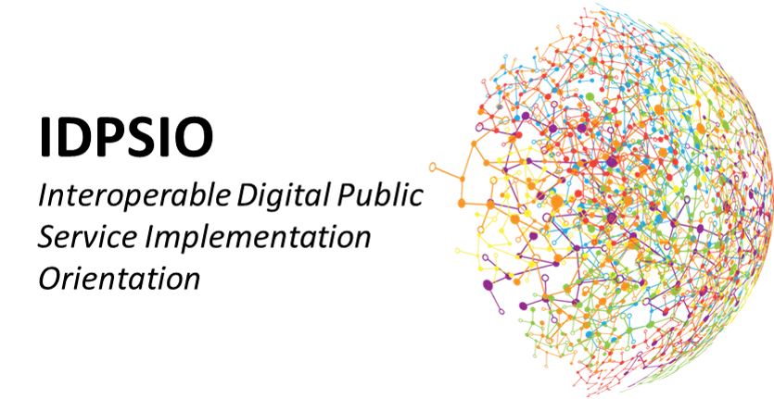

TABLE OF CONTENTS

1 Introduction 2

1.1 Purpose of this document 2

1.2 Release date 2

1.3 List of acronyms used in this document 2

2 Release components 3

2.1 IDPSIO V2.0.0 Herokuapp 3

2.2 Joinup 4

# Introduction

## Purpose of this document

This document contains the description of the release version 2.0.0 of the Interoperable Digital Public Services Implementation Orientation (IDPSIO)

## Release date

This version of the IDPSIO has been released on 22 of April 2022 in [Joinup.](https://joinup.ec.europa.eu/collection/european-interoperability-reference-architecture-eira/solution/egovera/release/v200)

## List of acronyms used in this document

Table 1-1

|  |  |
| --- | --- |
|  |  |
| IDPSIO | Interoperable Digital Public Services Implementation Orientation |
| PO | Project Officer |

# Release components

IDPSIO consists of the following release components

## IDPSIO V2.0.0 Herokuapp

IDPSIO consists of the following release components The IDPSIO (Interoperable Digital Public Services Implementation Orientation) Assessment Tool aims to supports digital public service owners in deciding the approach to follow in order to implement their digital public services. The IDPSIO model has been developed to support the Member States in understanding the implementation impacts from different angles: integration, technology, governance, and legal.

| Modification | Details |
| --- | --- |
| Version 2.0.0 | |
| Questions were updated | The content of the questions in the “DPS requirements in regulation” section, are updated and rephrased according to the detailed PO review |
| Scoring model was updated | The scoring of the survey has been updated according to updated version of the questions |
| Copyrights were updated | The copyrights of the survey have been updated |
| Product license was added | The ISA product license (v1.4) has been included in the side menu as a hyperlink |
| Supporting information was added | In the “Implementation Orientation” sections, extra information was added according to the detailed PO review |

## Joinup

The public web-page ([IDPSIO | Joinup (europa.eu)](https://joinup.ec.europa.eu/collection/european-interoperability-reference-architecture-eira/solution/egovera/release/v200)) containing information on the IDPSIO.