GIQAT v2.0.0

**Release notes**

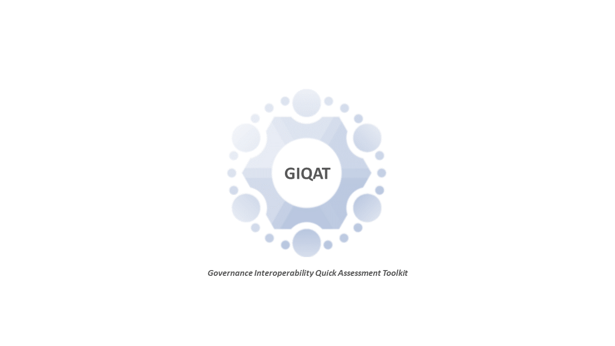



TABLE OF CONTENTS

1 Introduction 2

1.1 Purpose of this document 2

1.2 Release date 2

1.3 List of acronyms used in this document 2

2 Release components 3

2.1 GIQAT V2.0.0 EU SURVEY 3

2.2 Joinup 4

2.3 GIQAT_v2_0_0_release 4

Error! Hyperlink reference not valid.**Error! Hyperlink reference not valid.Error! Hyperlink reference not valid.Error! Hyperlink reference not valid.Error! Hyperlink reference not valid.**Error! Hyperlink reference not valid.**Error! Hyperlink reference not valid.Error! Hyperlink reference not valid.Error! Hyperlink reference not valid.Error! Hyperlink reference not valid.Error! Hyperlink reference not valid.Error! Hyperlink reference not valid.Error! Hyperlink reference not valid.Error! Hyperlink reference not valid.**

# Introduction

## Purpose of this document

This document contains the description of the release version 2.0.0 of the Governance Interoperability Quick Assessment Toolkit (GIQAT).

## Release date

This version of the GIQAT has been released on 09 of March 2022 in [Joinup.](https://joinup.ec.europa.eu/collection/european-interoperability-reference-architecture-eira/solution/giqat/about)

## List of acronyms used in this document

Table 1-1

|  |  |
| --- | --- |
|  |  |
| GIQAT | Governance Interoperability Quick Assessment Toolkit |

# Release components

GIQAT consists of the following release components

## GIQAT V2.0.0 EU SURVEY

The Governance Interoperability Quick Assessment tool supports a short and comprehensive questionnaire to collect information on the solution from the solution owner, in order to automatically calculate its maturity from the Interoperability Governance perspective. The online assessment tool includes two key aspects: Collaboration Control and Collaboration Assurance, with closed answers, and implements the defined Governance Interoperability Scoring Model. The tool is implemented in EU survey in order to be easily used by any solution owner.

| Modification | Details |
| --- | --- |
| Version 2.0.0 | |
| Items were updated | The content of the items has been updated according to the detailed PO review |
| Scoring model was updated | The scoring of the survey has been updated according to updated version of the items |
| Logo was added | The logo of the survey has been included in the side menu |
| Product license was added | The ISA product license (v1.4) has been included in the side menu as an hyperlink |
| Contact information was updated | The contact information has been updated and it is present in the side menu |
| Reporting abuse was added | Reporting abuse has been included in the side menu by means of a hyperlink and pop-up message |
| The survey layout was updated | The surveys theme/layout has been updated (accessibility mode layout provided by the EU survey platform) coherently with the IMAPS survey |
| Disclaimer was added | The display of the disclaimer and the privacy statement, has been inserted in the page before the introduction. |
| Terms and Conditions restrictions were added | Users are not allowed to view the content of the Survey if they have not agreed on the Terms and Conditions |
| Background information were updated | The Introduction section includes the user inputs as well as background information about the survey |
| Expected profiles were added | In the Introduction section there is added information about the expected profiles per section (e.g. the survey targets end-users who have expertise in law-making, policymaking & decision-making such as policymakers and decision-makers) |
| Position of the questions was updated | The position of the questions in the Introduction section has been updated, to ensure consistency among the interoperability assessment toolkits. |
| Styling of the sections was updated | The surveys sections’ title styling is updated to ensure it is consistent throughput the survey |
| Navigation titles were added | The sections titles have been included in the top navigation and progress bar |
| Styling of questions was updated | The surveys questions styling has been updated to ensure it is consistent throughput the survey |
| Numbering of questions was updated | The surveys questions numbering has been updated to ensure it is consistent throughput the survey |
| EIF Interoperability view was added | Bellow every question a text field is added that describes the EIF Interoperability View. |
| Interoperability Enabler and Interoperability manifestation text fields were added | Bellow every question a text field has been added to describe whether the question refers to enabler or manifestation. |
| PURIs links were updated | The PURIs links that are present in the questions have been updated  Note: in the next contract those PURIs will be updated with the latest version of EIRA |
| Summarise box was included | At the bottom of every section, it has been included a comment summarize box that the user could use |
| Rating feedback was created | A new page has been created to allow rating to be provided by the users as feedback |



























## Joinup

The public web-page ([About Governance Interoperability Quick Assessment Toolkit | Joinup (europa.eu)](https://joinup.ec.europa.eu/collection/european-interoperability-reference-architecture-eira/solution/giqat/about)) containing information on the GIQAT.



## GIQAT_v2_0_0_release

The public web-page ([GIQAT | Joinup (europa.eu)](https://joinup.ec.europa.eu/collection/european-interoperability-reference-architecture-eira/solution/giqat/release/v200)) containing the release notes on the GIQAT.