

**EU Cloud Taxonomy**

**Document Metadata**

|  |  |
| --- | --- |
| Property | Value |
| Release date | 30 June 2022 |
| Status | Approved |
| Version | Version 1 |
| Authors | Philippe Merle  Victor BOULANGER  Cecile.GUASCH  Zsofia Dudas |
| Reviewed by | Seth VAN-HOOLAND |
| Approved by | Seth VAN-HOOLAND |

|  |
| --- |
| The latest version of this controlled document is stored in: |
| Disclaimer |
| This report was prepared for the ISA2 programme by PwC EU Services.  The views expressed in this report are purely those of the authors and may not, in any circumstances, be interpreted as stating an official position of the European Commission.  The European Commission does not guarantee the accuracy of the information included in this report, nor does it accept any responsibility for any use thereof.  Reference herein to any specific products, specifications, process, or service by trade name, trademark, manufacturer, or otherwise, does not necessarily constitute or imply its endorsement, recommendation, or favouring by the European Commission.  All care has been taken by the author to ensure that s/he has obtained, where necessary, permission to use any parts of manuscripts including illustrations, maps, and graphs, on which intellectual property rights already exist from the titular holder(s) of such rights or from her/his or their legal representative. |

**Table of Contents**

1. Explanatory note 4

2. Terms 6

# Explanatory note

**Objective**

The objective of this taxonomy is to provide common definition for the most used cloud terminology for EU procurement practitioners. Defining these terms can help to maximize the efficiency of the procurement procedures both for the public administrators and the private actors.

**Methodology**

Throughout the means of desk research and in collaboration with the Member States and the Commission, various documents have been collected. These documents capture the terms and definitions used by the Member States, European Commission, other industry standards and private players in relation to cloud services.

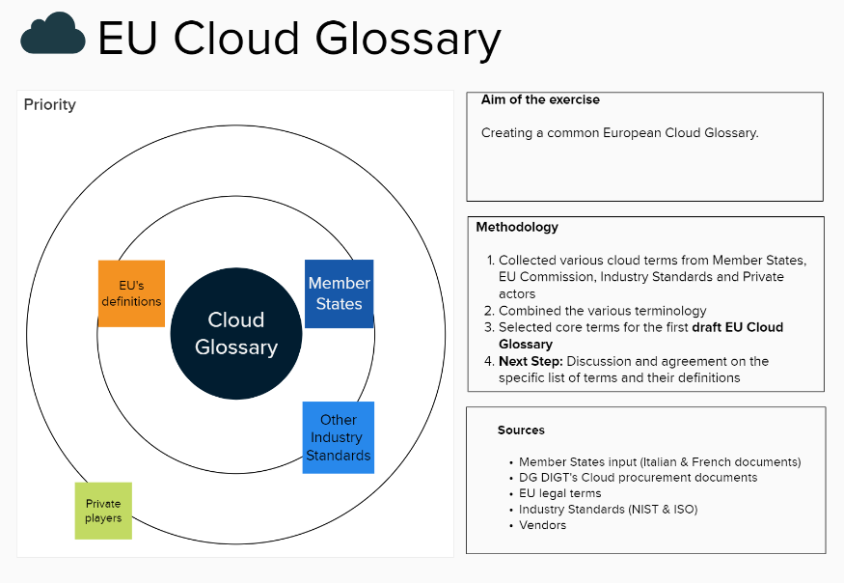

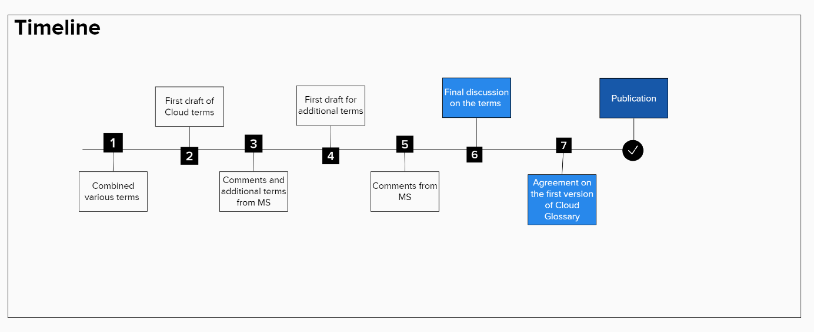

**MSCCG meetings**

DG DIGIT and DG CONNECT worked close with Member States to reach agreement on the most important terms for first unofficial EU Cloud Glossary.

Throughout two separate meetings in the context of the Session of the informal Member State Cloud Cooperation Group, the Member States with the European Commission has agreed on the first set of terms and their definitions.

6th MSCCG – 21 April

**The first draft version of a consolidated EU glossary of cloud terms was shared with the Member States**. This document was created based on the national glossaries that the Commission received. During the meeting Member States discussed what terms should be included in the first draft and if there are any terms that were missing. The Member States were provided with a commenting period.

8th MSCCG – 21 April

The second draft version included the comments received from the Member States. Some terms were highlighted by the Member States which in their view needed to be discussed more in detail. During this meeting these comments were discussed, and the Member States agreed on that the first version can be published.

**Disclaimer:** *Please note that the below definitions are not binding and are used for practical implementation of public procurement procedures. The document might be updated considering upcoming change request.*

# Terms

**Service models**

**Cloud Services:** IT services delivered according to the cloud computing paradigm. These services enable ubiquitous, scalable, convenient, on-demand network access to a shared elastic pool of configurable physical or virtual resources (such as networks, servers, storage, applications, and services) that can be rapidly provisioned and released with minimal management effort or service provider interaction.

**IaaS (Infrastructure as a Service): IaaS is** a cloud service category. The Cloud capabilities provided to the consumer include provision processing, storage, networks, and other fundamental computing resources where the cloud service customer (i) is able to deploy and run arbitrary software, which can include operating systems and applications; and (ii) does not manage or control the underlying cloud infrastructure but has control over operating systems, storage, and deployed applications, and possibly limited control of select networking components (such as host firewalls).

**PaaS (Platform as a Service): PaaS is** a cloud service category. The capability provided to the consumer is to deploy, manage and run onto the cloud infrastructure applications created or acquired by the consumer using one or more programming languages, libraries, services, execution environments and tools supported by the Contractor. The consumer does not manage or controls the underlying cloud infrastructure including the network, servers, operating systems, or storage, but has control over the deployed applications and possible configuration settings for the application-hosting environment. Web services available as on-demand APIs to build applications are considered PaaS services.

**SaaS (Software as a Service): SaaS is** a cloud service category. The capability provided to the consumer is to use the provider’s applications running on a cloud infrastructure. The applications are accessible from various client devices through either a thin client interface, such as a web browser (e.g., web-based email), mobile application or desktop application, and possibly complemented by program interface specific to the software. The consumer does not manage or control the underlying cloud infrastructure including network, servers, operating systems, storage, or even individual application capabilities, with the possible exception of limited user specific application configuration settings.

**aPaaS (Application Platform as a Service):** aPaaS is a sub-category of SaaS services. The capability provided to the consumer is a SaaS platform that offers development and deployment environments for application services. The consumer does not manage or control the underlying cloud infrastructure including network, servers, operating systems, storage, or even individual application capabilities, with the possible exception of limited user specific application configuration settings but control the development life cycle of the application delivered.

**Types of Clouds**

**Private Cloud:** Private cloud is a cloud deployment model. The cloud infrastructure implements some of the cloud computing concepts (e.g. on-demand self-service, broad network access, resource pooling, rapid elasticity, measured service). The cloud infrastructure is provisioned for exclusive use by a single organization comprising multiple consumers (e.g., business units). It may be owned, managed, and operated by the organization, a third party, or some combination of them, and it may exist on or off premises.

**Community Cloud:** Community cloud is a cloud deployment model. The cloud infrastructure implements some of the cloud computing concepts (e.g. on-demand self-service, broad network access, resource pooling, rapid elasticity, measured service). The cloud infrastructure is provisioned for exclusive use by a specific community of consumers from organizations that have shared concerns (e.g., mission, security requirements, policy, and compliance considerations). It may be owned, managed, and operated by one or more of the organizations in the community, a third party, or some combination of them, and it may exist on or off premises.

**Public Cloud:** Public cloud is a cloud deployment model. The cloud infrastructure implements most of the cloud computing concepts (e.g. on-demand self-service, broad network access, resource pooling, rapid elasticity and measured service). The cloud infrastructure is provisioned for open use by the general public. It may be owned, managed, and operated by a business, academic, or government organization, or some combination of them. It exists on the premises of the cloud provider and is multi-tenant by nature. Data of consumers of the services are isolated from one-another by means included in the cloud service and not publicly available to the public except consumers decide so.

**Hyperscaler:** A hyperscaler is a public cloud provider with a worldwide footprint, providing virtually infinite scalability and an extensive catalogue of managed services. The cloud infrastructure of a hyperscaler implements some or all (depending on the cloud type) of the cloud computing concepts (e.g. on-demand self-service, broad network access, resource pooling, rapid elasticity an/or measured service).

**Hybrid Cloud:** The cloud infrastructure is a composition of two or more distinct cloud infrastructures (private, community, or public), or infrastructures without cloud computing capacities (e.g. costumer/ organisations’ data centers) that remain unique entities, but are bound together by standardized or proprietary technology that enables data and application portability (e.g. cloud bursting for load balancing between clouds).

**Multi-Cloud:** The capability provided to the consumer is to use cloud services provisioned by multiple cloud infrastructures, possibly from multiple providers, of the same deployment model. It differs from the hybrid model which involves the combination of public and private cloud.

**Purchased goods, Type of services, Types of deliverables**

**Products:** Product as described in the Contract, consisting of one or more tangible or intangible asset(s) resulting from a manufacturing or development process. Products include Hardware Products and Licensed Software Products or parts thereof. Hardware Products and Licensed Software Products are considered as supplies when the latter term is used in the Contract.

**Hardware:** Any tangible asset resulting from a manufacturing process and consisting of computer, media, electronic communications, or other electronic equipment, whether or not it embeds Software, as well as all accessories related to such equipment.

**Software:** Any intangible asset resulting from a development process and consisting of a computer program or a part thereof.

**Licensed Software Products:** Software of which intellectual property rights are held by the Contractor or a third party, whether customised or not to meet the Contracting Authority's specific requirements and licensed to the Contracting Authority under the Contract.

**Services:** Services as described in the Contract, involving the application of business and technical expertise. By default, Services include all Deliverables that are not Products.

**Support Services:** All standalone or ancillary support, assistance, planning, maintenance, training, consulting, managing, auditing and/or integration Services related to information technology, as further described in the Contract.

**Evolutive Maintenance:** All operations undertaken to enhance the functionalities of a Product, including but not limited to adding additional functionalities or replacing existing functionalities with other functionalities, in order to increase the Product's performance even in the absence of faults, deficiency, malfunctioning or nonconformity.

**Preventive Maintenance:** All operations undertaken to prevent faults, deficiencies, malfunctioning or nonconformities from occurring, or to prevent them from developing into major defects, and to maintain the Product in normal operating condition. Preventive Maintenance includes but is not limited to systematic inspection, tests, measurements, adjustments, correction, parts replacement, and cleaning.

**Measurement**

**Key Performance Indicators:** Measurable targets serving as a reference to determine the level of performance of a Service.

**Service Level Objective:** Documented quality objective targeted by the consumer of a cloud service or proposed by the provider of the cloud service, but without commitment of the provider towards the consumer.

**Service Level Agreement:** The cloud computing service level agreement (cloud SLA) is a service level agreement between a cloud service provider and a cloud service customer based on a taxonomy of cloud computing specific terms to set the quality of the cloud services delivered.It also foresees the applicable liquidated damages and/or compensations in case the level of service does not meet these expectations.

**Actors** (specific to cloud)

**Initial Vendor:** public or private entity that exploits and provides a Product or a Service, under its trademark or sign, or under the trademark or sign of one of its related companies.

**Cloud Broker:** public or private entity that serves as both an IT role and service business model, whereby a service provider or another entity adds value to one or more cloud services on behalf of one or more consumers of those services. Value can be added via four primary roles: Aggregation, Integration, Customization or Governance. The cloud broker is an entity that is the aggregated paying entity on behalf of all other participants entities/customers.

**Additional Cloud terms**

**Reversibility:** Reversibility is the extent to which cloud-based products or services can be moved to other cloud providers or environments. Reversibility can cover architecture patterns, but also contract clauses that support changing cloud providers and avoid unforeseen costs of obligation when customers leave the cloud service.

**Portability:** Cloud portability is the ability to move applications and data from one cloud computing environment to another with minimal disruption. Cloud portability enables the migration of cloud services from one cloud provider to another or between a public cloud and a private cloud.

**Multi-tenant:** Software multitenancy is a software architecture in which a single instance of software runs on a server and serves multiple tenants. Systems designed in such manner are "shared" (rather than "dedicated" or "isolated").

**Tenant:** A tenant is a group of users who share a common access with specific privileges to the software instance. Public cloud services are by nature multi-tenant.

**Availability zone:** Availability zones (AZs) are isolated locations within data centre regions from which public cloud services originate and operate.

**Region:** Regions are geographic locations in which public cloud service providers' data centres reside.

**Geographical control over data:** The ability of a cloud service customer to control the geography where its data are residing. The control can apply at the level of a Region, or an Availability Zone or any other concept that refer to a geography. Control stands for the guarantee that data are not moved by the cloud provider without the explicit consent of the customer, provided by any mean (e.g. configuration portal, API) (*in transit and rest).

**CloudOps:** Cloud Operations (CloudOps) refers to any managerial activities related to the continuous updates or optimizations of IT services being run through a cloud service. In other words, CloudOps is the process of identifying and following appropriate operational procedures to optimize IT services within any given cloud environment.

**Cloud Native:** Cloud-native is an approach to building and running information systems that exploit the advantages of the cloud computing delivery model. Cloud-native is about how information systems are created and deployed. It implies that the information system  
 reuses existing cloud-based services, instead of relying on purpose-built data centre infrastructure services. (European Cloud Strategy)

**Cloud Federation:** "The purpose of the EU Cloud Federation is to cater for European standards and reference architectures to create EU-based ‘virtual hyperscale providers.

**Cloud Adoption Framework:** Framework or methodology that an organisation can follow to organise and govern the changes required to the adoption of the cloud computing paradigm.

**Cloud migration:** The activity of migrating workload from traditional IT environments (e.g. datacentre) to cloud services.

**Cloud Computing:** "Cloud computing" is an IT paradigm that enables ubiquitous access to shared pools of configurable system resources and higher-level IT services that can be dynamically provisioned with minimal management effort, usually over the Internet. Cloud computing relies on the sharing of resources to achieve coherence and economies of scale, similar to a public utility.

**Cloud Exit Strategy:** The strategy defined by a cloud customer to change cloud provider in the event the provider would cease activity or would become economically no longer viable to for the operations of the customer.

**Value chain:** A value chain is a set of activities that a firm operating in a specific industry performs in order to deliver a valuable product (i.e., good and/or service) to the end customer.

**Supply chain:** A system within organisations, people, activities, information, and resources involved in supplying a product or service to a consumer. Supply chain activities involve the use or transformation of IT services or products into a finished product and delivering the same to the end customer. Supply chains link value chains. Suppliers in a supply chain are often ranked by "tier", first-tier suppliers being those who supply direct to the client business, second tier being suppliers to the first tier, etc.

**Product and Services lifecycles;** A product or service life cycle is the length of time from a product or service first being introduced

**Reusable component:**An IT product or service which is designed to be used in the context of several products or services. Reusable components can be libraries integrated within a product, or managed services used by another product or service.

**Health Dashboard:** Visualisation portal where statistics informing customers about services and products operational status (availability, level of performance, load...).

**System generated Data:**Data generated by the cloud services, providing information about the cloud services and exploited by the customer or the cloud provider for the purpose of managing the services (e.g. availability, auditability, performance). System data may not be accessible to the customer.

**Key Management:** All operations and services referring to the management of cryptographic keys.

**Carbon footprint:** A term used popularly to refer to the overall quantity of CO2 and other greenhouse gas emissions caused directly and indirectly by a product or an activity or associated with the activities of an individual or an organisation. No mandatory EU rules exist for calculating carbon footprints.

**Data location:** Geographical boundaries where data are residing. Geography can be at the level of a Region, or an Availability Zone or any other concept that refer to a geography (*in transit and rest)[1].

**Data Security:** IT security measures focused on providing security for customer data at large. Security refers to security dimensions Confidentiality, Integrity and Availability (CIA).

**Subcontractor:** Subcontractor: A role of an agent that has an agreement with another agent to perform part or all of the obligations of that other agents’ contract. Additional information: for some procedures, the subcontractor signs as well the contract between the buyer and the contractor. At tendering time, entities relied upon by the economic operators can be subcontractors or not. When modelling ESPD we well analyse whether we need or not a role named "relied upon".

**Incident:** Unplanned interruption to a service or reduction in the quality of a service. Each incident should be logged and managed to ensure that it is resolved in a time that meets the expectations of the customer and user.

**Data Governance:** Data governance refers to a set of rules and means to use data, for example through sharing mechanisms, agreements and technical standards. It implies structures and processes to share data in a secure manner, including through trusted third parties.

**Data classification:** The process of categorising data into relevant subgroups that aims at defining management rules for the classified data.

**Software bill of material (supply chain):** A software Bill of Materials (SBOM) is a list of all the open source and third-party components present in a codebase. An SBOM also lists the licenses that govern those components, the versions of the components used in the codebase, and their patch status, which allows security teams to quickly identify any associated security or license risks

**Confidential Computing:** Confidential Computing protects data in use by performing computation in a hardware-based Trusted Execution Environment. These secure and isolated environments prevent unauthorized access or modification of applications and data while in use, thereby increasing the security assurances for organizations that manage sensitive and regulated data.

**Vendor lock-in:** Vendor lock-in happens when the public authority cannot easily change a provider after procuring an ICT product or service, because not all essential information about the system is available for efficient takeover by another provider.[2]

*Additional information on reducing vendor lock-in:* [*Study on best practices for ICT procurement based on standards in order to promote efficiency and reduce lock-in*](https://op.europa.eu/en/publication-detail/-/publication/152a29e9-e10c-11e5-8a50-01aa75ed71a1)

**DevOps:** DevOps is a combination of software developers (dev) and operations (ops). It is defined as a software engineering methodology which aims to integrate the work of software development and software operations teams by facilitating a culture of collaboration and shared responsibility. DevSecOps adds a security responsibility (sec) to the team and the paradigm.

**Containerization;** The activity of re-platforming an application to operate it using container technologies, which refers to a fully functional and portable cloud or non-cloud computing environment surrounding the application and keeping it independent from other parallelly running environments. Individually each container simulates a different software application and runs isolated processes by bundling related configuration files, libraries and dependencies. However, collectively multiple containers share a common OS Kernel.

**Encryption in transit:** The process of converting information or data into a cryptographic code during transfer of data, between compute or storage layers.

**Encryption at rest:** The process of converting information or data into a cryptographic code in the storage layer, i.e. when data are not used in storage of compute layers.

**Encryption:** The process of converting information or data into a cryptographic code, especially to prevent unauthorized access.

**Consumer/Customer data:** Data produced and used by a customer of a service or product, in the context of this product or service.

**Service Data:** Data produced by a provider of product or service, for the purpose of monitoring or maintaining the product or service for the benefit of the customer. The customer may or may not have access to service data, their list or the data themselves.[3]

**Data Latency:** Delay upon which data are available for processing by a product or service.

**Mutual recognition of standards:** Mutual recognition occurs when two or more countries or institutions recognize one another's decisions or policies, for example in the field of conformity assessment, professional qualifications or in relation to criminal matters

**Interoperability:** Interoperability means the ability of disparate and diverse organisations to interact towards mutually beneficial and agreed common goals, involving the sharing of information and knowledge between the organisations, through the business processes they support, by means of the exchange of data between their respective information and communication technology (ICT) systems.

**Datacentre:** A large group of networked computer servers typically used by organizations for the remote storage, processing, or distribution of large amounts of data.

**Compute:** Concepts and objects related to software computation. It is a generic term used to reference processing power, memory, networking, storage, and other resources required for the computational success of any program.

**Storage**: Electronic, electrostatic, or electrical hardware or other elements (media) into which data may be entered, and from which data may be retrieved.

**Network:** A system implemented with a collection of connected components. Such components may include routers, hubs, cabling, telecommunications controllers, key distribution centres, and technical control devices.



**An action supported by ISA²**

ISA² is a EUR 131 million programme of the European Commission which develops digital solutions that enable interoperable cross-border and cross-sector public services, for the benefit of public administrations, businesses and citizens across the EU. ISA² supports a wide range of activities and solutions, among which is the Semantic Interoperability Community (SEMIC) action.

ISA² solutions can be used free of charge and are open source when related to IT.

**More on the programme**

[ec.europa.eu/isa2](https://ec.europa.eu/isa2/home_en)

**Contact ISA²**

[isa2@ec.europa.eu](mailto:isa2@ec.europa.eu)

**Follow us**

[@EU_ISA2](https://twitter.com/EU_ISA2)

[@Joinup_eu](https://twitter.com/Joinup_eu)



[isa2 programme](https://www.linkedin.com/in/isa2programme/)

1. In transit:

   Rest:
2. Vendor lock-in, also known as proprietary lock-in or customer lock-in, makes a customer dependent on a vendor for products, unable to use another vendor without substantial or prohibiting switching costs. The use of open standards and alternative options makes systems tolerant of change, so that decisions can be postponed until more information is available or unforeseen events are addressed. Vendor lock-in does the opposite: it makes it difficult to move from one solution to another.
3. **Service data includes :**  
   1. “Diagnostic Data” which are data, including telemetry data, collected or obtained, by a provider from locally installed software.  
   2. “System Generated Data” are data generated by the provider through the operation of an Online Service.