**Artefact 2: ESS EARF Principles**

31 August

Version 1.1



Table of Contents

1.0 Description 2

2.0 Proposed use 4

3.0 Artefacts 4

3.1 Project go-no go 5

Projects build on solid cost-benefit analysis 5

Projects deliver re-usable capabilities 5

Projects deliver capabilities that are sustainable 6

Innovation is a focus area 6

Projects deliver products that are useful to users 6

3.2 Project design 7

Projects use an adaptive project management approach 7

Projects are designed to continuously deliver outputs & outcomes 7

Projects keep in mind and embed security requirements as of the design phase 8

3.3 Information system architecture 8

Information throughput is needs-based 8

Information is available for reuse 9

Communication with externals is adaptive and flexible 9

Processes and systems are configurable 10

Processes are automated 10

Existing standards are used where applicable 10

New standards are developed where necessary 11

Reuse is considered before adapt before buy before build 11

Scalability is an important consideration 12

Security is built in 12

Quality control is built in 12

Annex: Mapping of ESS EARF Principles to other key sources for Principles 14

1. Description

Principles are **general rules** and guidelines, intended to be enduring and seldom amended, that inform and support the way in which an organization sets about fulfilling its mission.[1]

The figure below depicts the ESS Enterprise Architecture Reference Framework metamodel and the role of the principles in relation to it.

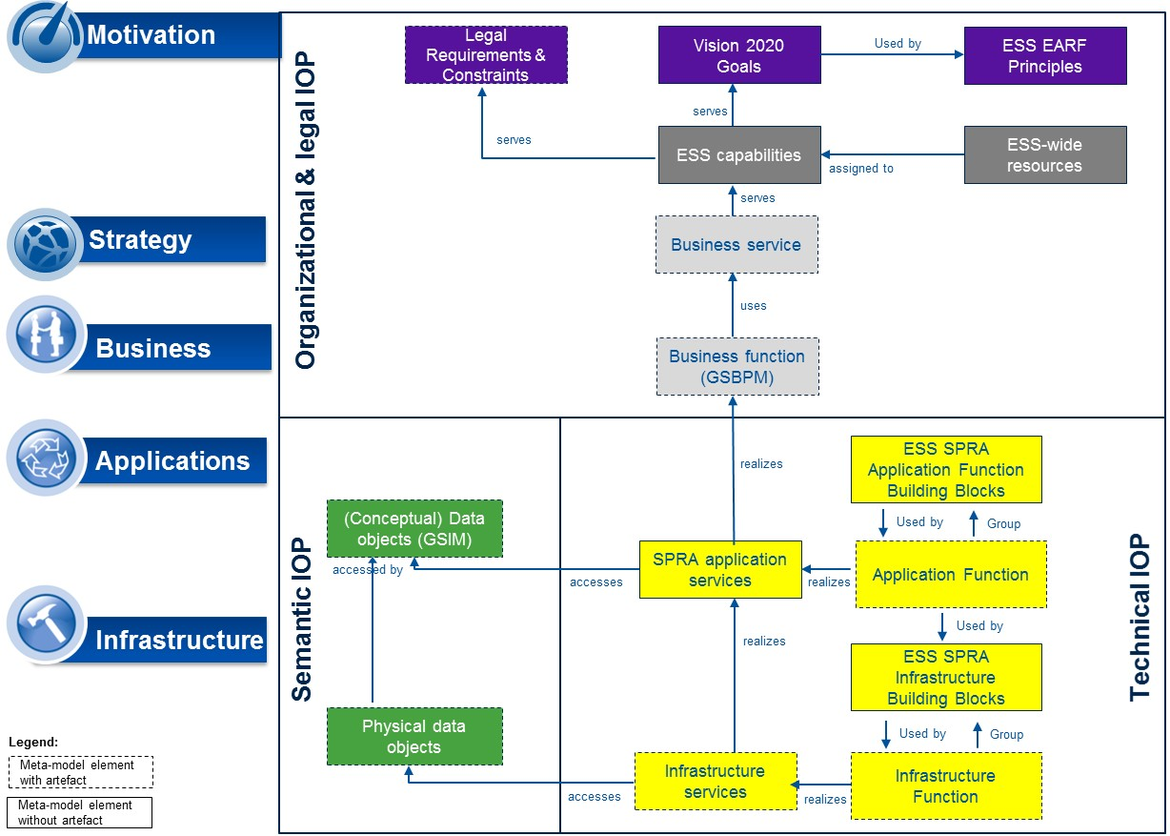

1. The ESS EARF principles in the ESS EARF metamodel

There is a set of Principles that apply to official statistics in general; this set is thus universally relevant to all ESS participants:

* The Fundamental Principles of Official Statistics: These Principles were adopted by the United Nations Statistical Commission in April 1994.[2]
* Principles Governing International Statistical Activities: The Committee for the Coordination of Statistical Activities adopted the Fundamental Principles of Official Statistics, and endorsed the Declaration of Good Practices in Technical Cooperation in Statistics.[3]
* The Fundamental Principles of ESS Official Statistics: These Principles are outlined in the:
  + - “European Statistics Code of Practice”[4]
    - Legal Frameworks for European Statistics such as in Regulation 223/2009[5] and in the
    - Quality Assurance Framework of the European Statistical System[6].

Further, pan-European collaboration between administrations builds on the Principles of the European Interoperability Framework for European public services (EIF) that, amongst other, supports the delivery of European public services by fostering interoperability and guides public administrations in their work to provide services to businesses and citizens.[7]

Even though these Principles are not specific to the implementation of Vision 2020, it is important to restate their applicability. “Annex: Mapping of ESS EARF Principles to other key sources for Principles” provides a comprehensive mapping of the stated Principles.

As a guiding rule, Principles should **be few in number**, **future-oriented**, and endorsed and **championed by senior management**. They provide a firm foundation for making architecture and planning decisions, framing policies, procedures, and standards, and supporting resolution of contradictory situations. Essentially, Principles are meant to drive behavior ensuring that the projects launched under the [Vision 2020](https://ec.europa.eu/eurostat/web/ess/about-us/ess-vision-2020) implementation program will realize the objectives of the Vision.

The ESS EARF identifies **three key situations** in which the ESS EARF Principles will be of great use:

1. To take a **project go-no go** decision: The ESS EARF Principles support managers to decide on which projects to select to implement the ESS Vision 2020. They complement the more general criteria for ESS Vision project selection defined by the ESSC and should be applied in the Project Initiation Phase.
2. In **project design**: The ESS EARF Principles also apply to the design of the project. They should be applied by project architects in the designing stage of their projects in view of maximizing benefits and business value. Whether the Principles have been adhered to should then be checked again at the end of the design phase.
3. In the elaboration of an **information system architecture**: The ESS EARF Principles guide the setting up of the information system architecture to be implemented by the project. They ensure that the project- specific architecture will integrate in the global ESS architecture and contribute to the establishment/improvement of target ESS Business Capabilities. As stated under the previous list point, it should again be verified at the end of the design phase whether the Principles have been adhered to.
4. Proposed use

A well-communicated, robust set of EA Principles is the foundation for effective governance and architecture compliance, and lays the groundwork for other governance mechanisms such as steering committees, architecture boards and so on. The next table depicts the key use cases for the ESS EARF Principles.

|  |  |
| --- | --- |
| **Used by** | **For what purpose** |
| Usage by ESS governance | * Are a key tool to resolve issues amongst ESS projects. * Ensure continuity and consistence in decision making. * Can complement or be integrated in the list of go-no go criteria to be operationalized by the VIG. * Lay the ground rules for all ESS projects; projects which are non-compliant can thus be called to comply on their grounds. |
| Usage by ESS Enterprise architects  http://www.clker.com/cliparts/5/2/q/K/V/H/teacher-hi.png | * Are used as reference points for discussions with projects both in the ESS as well as with its individual members. * Ensure proper architectural design, taking into account concerns such as standardization, reuse, cost effectiveness and user centricity |
| Usage by ESS Business Leaders | * Are endorsed by business leaders and can be used as a tool in guiding IT. * Are used to check alignment with NSI-specific Principles and ideally aligned between ESS members and the ESS overall. |
| Usage by ESS project architects | * Are used as guidelines for designing approaches and systems so that they adhere to the target architecture. * Act as guidelines for the formulation of more detailed design principles. |
| Usage by ESS IT Leaders  C:\Users\blorincz\Documents\Collab BM TAXUD\Benchmark\shadow of face.jpg | * Are used as guidance for decision making. * Are used to check alignment with NSI-specific principles and ideally aligned between ESS members and the ESS overall. |

Table Use cases for the EA principles

1. Artefacts

**EA Principles for the ESS EARF**

The below tables contain the description of the ESS EARF Principles. The Principles are grouped according to the different situations in which they should be deployed.

* 1. Project go-no go

Projects that do not adhere to the following Principles should not be launched under the ESS Vision Implementation Program (they should receive a no-go)[8]:

|  |  |
| --- | --- |
| **Name** | Projects build on solid cost-benefit analysis |
| **Statement** | Projects build on solid cost-benefit analysis, to identify the most viable project scenario and anticipate cost and benefits *across* the ESS *and* over time. Any such analysis should thus cover cost & benefits accruing at the European as well as at the national Level. In the project’s design phase, the total cost of ownership of the project (showing investment cost and operating expenditures distributed over the lifetime of the project) are to be estimated compared to its benefits. This analysis indicates which project implementation scenario will yield the most adequate project results. Each project should present at a minimum 2 possible implementation scenarios. During the implementation phase, investments and operational expenditures are to be tracked compared to the accruing benefits, in accordance with the initial business case. The tracking can be done at pre-defined points in time (so-called gateway points), at which the project may be altered depending on the analysis’ results. |
| **Rationale** | * By systematically implementing business case and cost tracking methods, projects and project scenarios become comparable * Investment/disinvestment choices are objectivized * It becomes visible at what Level (European, national) cost & benefits accrue, and at what point in time * Cost are anticipated * Cost are controlled * National and European investments can be planned ahead, respecting individual investment cycles |
| **Implications** | * There needs to be a standard, solid method for business case analysis and TCO * There needs to be a data base into which projects report * The implications of the analysis on financing and governance need to be made explicit |
| **Name** | Projects deliver re-usable capabilities |
| **Statement** | Projects that deliver capabilities must ensure that the benefits of their effort are maximized. One way of achieving this is to ensure that the delivered capabilities can be used for as many different purposes as realistic within the context of the project. For each project, multiple potential users must be identified and their requirements taken into consideration when proposing an ESS project. |
| **Rationale** | * Having more users identified guarantees multiple users and hence reuse * Deliverables are reusable * Creates reusable capabilities, potentially even across statistical subject matter domains * User needs & requirements are determined and responded to in the earliest stages of a project |
| **Implications** | * Need to identify multiple users for suggested project deliverable * Need to collect requirements from those users * Need to consolidate requirements into one coherent set of requirements * Need to design for delivering to multiple users/environments; solution must be adaptable to these different circumstances |
| **Name** | Projects deliver capabilities that are sustainable |
| **Statement** | Projects deliver capabilities that are sustainable over the envisioned lifecycle, meaning that the capabilities delivered by the projects are maintainable for the time span they are intended to be used across. The project’s business case should clearly state what the intended lifecycle is (see next Principle). Generic capabilities that are used in multiple processes for producing diverse products in general have longer lifecycles. The longer the lifecycle, the more there is a need for adaptability such that the capability can be changed to meet future needs. |
| **Rationale** | * Capabilities are the fabric of the statistical organization * Investments need good ROI * ROI is typically better if benefits can be reaped over a longer period |
| **Implications** | * Project proposals with short term views should be scrutinized before approval * By necessity, capabilities must be adaptable to changing circumstances and requirements |
| **Name** | Innovation is a focus area |
| **Statement** | Besides running the day-to-day business, statistical organizations must adapt to changing circumstances. Projects considered under the ESS should have a clear focus on innovation. Innovation is necessary and must get sufficient attention and funding. Resources must be made available to design new products, methods and processes. |
| **Rationale** | * Innovation is the only way to change. * Change is needed in order to stay relevant in a fast-evolving environment. |
| **‍Implications‍** | * Always consider what the innovative element is in the proposed project. * Innovative solutions are (in essence) to be favored over conservative ones. * Separate funding for innovation activities that might not deliver expected results (but will deliver knowledge, learning) must be ensured * Measures must be taken to limit the risk of potential failures. There is a risk that (few) successes will emerge compared to (many) outcomes that "only" deliver knowledge and learning |
| **Name** | Projects deliver products that are useful to users |
| **Statement** | Statistical output is useful if the information describes relevant topics, i.e. if it is understandable, unambiguous and if the data is sufficiently accurate and timely. We further consider coherency between topics, consistency over time and comparability between regions and countries as different aspects of usefulness. |
| **Rationale** | * Delivering products that do not fulfill a user need constitutes waste and should be avoided * Statistical output only delivers value if it is used * No positive business case is possible unless user value is generated * ESS Vision 2020 recognizes different end user groups with different needs. However, given limited resources, the needs of users that together generate the most value should be prioritized |
| **Implications** | * Information needs of end users must be known * Products must be designed to fulfill an identified need * Products must have adequate (enough, but not more) quality in terms of detail, reliability and precision * Products must be designed to be unambiguous and understandable * Products must be produced and delivered on time * Products must be delivered in a suitable form (presentation-wise, technology-wise) |

* 1. Project design

Projects owners must already in the design phase ensure their projects apply the following Principles:

|  |  |
| --- | --- |
| **Name** | Projects use an adaptive project management approach |
| **Statement** | Projects build iterative evaluation cycles into their project management approach, whereby evaluations can lead to changes in the course of the project (adaptations). Evaluations typically occur when interim deliverables are due. The deliverables can then be considered as stages to the project. Projects that develop in iterations constantly gather feedback to help refine their requirements. The end result is that the deliverables better meet (internal and/or external) user needs and are produced with minimal costs, within minimal time. Iterations are planned in systematically, usually rather rapid (every x weeks) and fixed in resources. Depending on the change requirement resulting from the evaluation, the most appropriate governing body is consulted on the feasibility and relevance of the adaptation to realize. |
| **Rationale** | * Projects can adapt (and save cost) as they get modified to fit changes to reality * Incremental and iterative project planning typically better suits evolving contexts or contexts that are defined at a high, visionary Level at their outset. In such cases, projects evolve through ongoing discovery. |
| **Implications** | * This requires that the right leaders and a strong program team are in place. * Project executives must be involved more strongly & continuously. * Project executives need to make faster decisions. |
| **Name** | Projects are designed to continuously deliver outputs & outcomes |
| **Statement** | Projects are designed to continuously deliver, i.e. release intermediate deliverables on their path to the final deliverable. This in practice implies that projects spanning across multiple planning periods are split into smaller sub-projects, each of them leading to a tangible and, where relevant, operational sub-deliverable. For this purpose, techniques such as automated testing, continuous integration and continuous deployment can be used, resulting in the ability to more rapidly, reliably and repeatedly push out deliverables, whilst at the same time lowering project risk. |
| **Rationale** | * Ensures that every change is releasable * Makes it easier to take into account interdependencies with other project’s deliverables * Makes visible project risks and sources for failure faster * The demonstration of success across the project’s life cycle maintains motivation & momentum around the project |
| **Implications** | * This requires a change in mind-set compared to project stakeholders being used to long cycle times and the sole release of final outputs * This also requires a change in mind-set on the side of project evaluators who need to be prepared to evaluate unfinished output and quickly steer improvements |
| **Name** | Projects keep in mind and embed security requirements as of the design phase |
| **Statement** | Security is a critical factor within (IT) projects and therefore it is crucial that it is included in the design phase. Building in security requirements at a later stage may compromise the effectiveness and the compatibility of the chosen security solution. |
| **Rationale** | * Security is a complex domain and should therefore be integrated as of the beginning * Projects that do not address the security aspect (timely) are exposed to greater risk with respect to data confidentiality, integrity and availability * Information is the key asset of official statistics. Information cannot be compromised by external and internal stakeholders or by unauthorized external parties * The sharing of confidential information requires that the flows of information are secured and access and usage is traceable |
| **Implications** | * Security requirements need to be known and defined in the design phase * Security requirements need to be aligned with and mapped to the business requirements * A security risk assessment must be conducted |

* 1. Information system architecture

The information system architecture of projects proposed for Vision 2020 implementation should adhere to the following Principles:

|  |  |  |
| --- | --- | --- |
| **Name** | Information throughput is needs-based | |
| **Statement** | Statistics should serve the needs of the stakeholders. Speaking in terms of the statistical production value chain, information is delivered as a product (output) at the end of the value chain. In the earlier planning and design phases of statistics, one would “Identify needs”, “Consult and Confirm needs”, and “Design outputs”. These different throughput phases in the production of statistics have different needs for information; both in terms of data and metadata. | |
| **Rationale** | * By focusing on information needs across the statistical value chain we avoid collecting, analyzing and processing information that is not used or needed * The respondent burden is lessened by avoiding collecting unnecessary data * Consistent information models and linkage description between processes * The information flow in a statistical production process should reflect the statistical output * The information should be of sufficient (but not necessarily higher) quality to meet the purpose of intended use | |
| **‍Implications‍** | * A deep knowledge of information requirements is a pre-requisite * Understanding of the process steps in producing statistics and the information needs in each process step * An understanding of the quality characteristics of information is essential to ensure the information’s appropriate use * Information is documented, both data and metadata * Standardization of information models in the statistical production chain | |
| **Name** | Information is available for reuse | |
| **Statement** | Information is an important asset for statistical institutions. Information should be available for reuse for both internal and external users, as well as ensuring that only one single authoritative source exists. | |
| **Rationale** | * This Principle is based on the need for better retrieval, and the possibility of increased reuse of information * Better policy management/control regarding secure access to data * Reduced response burden when reusing data across statistical subject matter domains * Opportunities for cost savings and efficiencies | |
| **Implications** | * Data need to be uniquely identifiable across systems * Well defined metadata is available and shared with externals where adequate * Well documented information models of the data based on standards should be available and shared with externals where adequate * Standardized interfaces to identify and retrieve data should be available * Governance of master data and metadata need to be established * For efficient reuse of information, one should avoid manual processing * Capabilities for exchanging information have to be available or have to be built for effective collaboration | |
| **Name** | | Communication with externals is adaptive and flexible |
| **Statement** | | Capabilities for dissemination should be built using the most appropriate communication channels as a way of ensuring adaptability to new user needs and technology developments.  The same applies to capabilities for communicating with data providers. As new technologies and data sources emerge, capabilities for data collection must be able to adapt to handling data collection in new ways. |
| **Rationale** | | * Capability sustainability * Development of technologies for communication is accelerating * Ensuring that the integration of new data sources for statistics and lowering the respondent burden are high priority |
| **Implications** | | * ‍‍The design of a capability for dissemination or collection will have to separate the core capability functionality from the functionality for communicating with external members‍‍ * Capabilities for communication must be able to handle varying mechanisms of communication such as push/pull and batch/stream * ‍Both formal and less formal communication standards can be used,‍ but the decision has to be based on an identification and evaluation of available standards * Communication capabilities also include feedback from external users towards statistical institutes * Externals do not require specific, disproportionate technological solutions in order to use statistical products |
| **Name** | | Processes and systems are configurable |
| **Statement** | | Processes and supporting systems are configurable. The execution of the process can be easily adapted to a changing context (i.e. varying quality requirement, other data sources, …). |
| **Rationale** | | * Production process will be rendered more flexible and can quickly adapt to new, emerging needs * Quality audit and improvements will be enabled through the analysis of process behavior and history * Cost of adaptation are significantly reduced * The possibility of effective reuse of processes and systems will significantly increase |
| **Implications** | | * The metadata structure are entirely specified in the design phase * Ensure that metadata are active at the design phase of production systems (active metadata are metadata that drive other processes and actions) * Process metadata can be managed (i.e. stored, edited, retrieved) * Process descriptions and metadata structures follow industry standards * When designing or upgrading processes and supporting systems, the focus is put on functional needs and decisions on technology are deferred as long as possible |
| **Name** | | Processes are automated |
| **Statement** | | Repetitive and multi-users processes are automated wherever possible. Manual interventions (especially for low value add tasks) are reduced to a minimum. |
| **Rationale** | | * Process automation reduces the risk of human processing errors in low value operations such as information acquisition and therefore contributes to increasing the quality of the statistical output * Automation significantly reduces processing time and human resource consumption allowing a refocusing of resources on higher value tasks |
| **Implications** | | * Information systems are fully configurable and auditable (possibility to trace and reproduce processes) * Information architecture (information and process models and standards) enables machine to machine communication * Quality control is built in in the system and quality reports and warnings are generated automatically and made available to the process owner (through e.g. a process dash boards) |
| **Name** | | Existing standards are used where applicable |
| **Statement** | | Standards can be formal or de facto in nature and ensure interoperability between products and solutions.  To reach interoperability in the context of pan-European eGovernment services, guidance needs to focus on open standards (in line with the “European Interoperability Framework for Pan-European eGovernment Services”) and existing standards in general. Use of standards is important in order to understand capabilities, and to be able to re-use services, in a consistent and comparable way.  Services that are made available based on standards will increase the value for stakeholders, and add value to consumers. When designing capabilities and services, existing standards thus need to be identified and evaluated. |
| **Rationale** | | * Making use of ‍existing standards ‍is necessary for building sustainable capabilities * Using standards increases the possibility of collaboration * Making use of standards enables the project to focus on delivering the core business functionality * Supports interoperability |
| **Implications** | | * The knowledge of applicable standards needs to be high * Methods for evaluating standards is a pre-requisite for projects * Whether or not to use a standard is a decision point for the project * Evaluations of standards should be made publicly available for the statistical community * There is an intent to use Open standards and avoid specific IT technologies or products |
| **Name** | | New standards are developed where necessary |
| **Statement** | | Standards are useful as agreements between parties that have decided to collaborate. Existing standards should be used wherever applicable. Where existing standards do not exist or prove to be insufficient, new standards should be developed and agreed upon. |
| **Rationale** | | * Standards are important prerequisites for efficient data exchange, reuse, collaboration, and interoperability * Standards are only needed if they are helpful, standards are means and should not become goals in themselves * No standards should be developed and agreed unless such a standard brings clear benefits to the community as a whole |
| **Implications** | | * Requires commitment from the parties collaborating under the ESS as a whole |
| **Name** | | Reuse is considered before adapt before buy before build |
| **Statement** | | The first, preferred option to cover an identified need should be to reuse an existing generic component (methods, definition, package/module/component/service …). If such functionalities are not readily available, the second option is to adapt a solution which already exists ideally in an OSS framework. If not appropriate, the third option is to buy an existing package (Common-off-the-shelf, abbreviated as COTS). Only when no such packages are available, the functionalities should be built. |
| **Rationale** | | * Reusing components minimizes development time and cost * Existing solutions which have already been tested in production are likely to be more robust and deliver to quality requirements |
| **Implications** | | * The business case systematically evaluates the different relevant alternatives * There is a need for a well governed catalogue describing, certifying and pointing to the reusable components * This Principle need to be balanced with the need to innovate and the need for sustainability. This type of choice requires a cost benefit analysis with a TCO perspective |
| **Name** | | Scalability is an important consideration |
| **Statement** | | Future needs of scalability are an important consideration when designing the context in which the capability will be embedded. Scalability considerations involve ensuring that the capability is able to handle a foreseeable expansion of the business scope and an increased number of active concurrent users. If scalability is not considered at the outset, there is a risk of a higher TCO as the business scope expands. |
| **Rationale** | | * Making sure a capability is scalable is an important factor for creating sustainable business processes * The lack of consideration of scalability in an early phase could have a significant negative impact when scalability becomes an issue |
| **Implications** | | * To decide on the correct Level of scalability it is required that the project understands the intended scope of usage * The project is required to have a strategic approach and take into consideration future usage of the capability |
| **Name** | | Security is built in |
| **Statement** | | Information assets and systems are guaranteed to be available, cannot be compromised and their access is controlled implementing the following dimensions of security: Availability, Integrity, Non-Repudiation and Confidentiality. |
| **Rationale** | | * Implementation of security is imposed in different legal provisions requesting different Levels of confidentiality * Information is the key asset of official statistics. Information cannot be compromised by external and internal stakeholders * We should maintain trust from our information providers. Ensuring security of data along their entire life cycle is the corner stone for building trust among ESS members * The sharing of confidential information requires that the flows of information are secured and access and usage is traceable * External risk (attacks) are increasing |
| **Implications** | | * ESS wide security architecture is developed and implemented * Systems are made security compliant with the adopted norms from the design stage on * Access to confidential information is appropriately restricted and monitored * Data ownership and data agents roles are clearly defined * Computing systems are able to cope with distributed resources and implementation * Those whose data is being used are informed of the purpose of the usage, the data protection measures taken and their rights stemming from the applicable confidentiality regulation |
| **Name** | | Quality control is built in |
| **Statement** | | Information systems and statistical services generate the metadata required to track, monitor and continuously improve the quality of statistical outputs, statistical processes and the characteristics of the institutional environment in which the statistics are being produced.  They make use of (where relevant reusable, else specific) capabilities to support preventive or corrective actions and ensure compliance with quality requirements as early in the statistical production chain as possible. |
| **Rationale** | | * Support realizing the ambition of Vision 2020 stating that “We manifest ourselves as the statistical conscience, which guides society through the information overload". |
| **Implications** | | * Metadata Management is an integral part of Quality management. * Statistical processing services are integral parts of Quality management. * Quality management capabilities are developed from an ESS perspective. |

# Annex: Mapping of ESS EARF Principles to other key sources for Principles

Figure 1 maps the ESS EARF Principles to

* The Fundamental Principles of ESS Official Statistics:
  + - “European Statistics Code of Practice”[9]
    - Legal Frameworks for European Statistics such as in Regulation 223/2009[10] and in the
    - Quality Assurance Framework of the European Statistical System[11].
* The European Interoperability Framework for European public services (EIF) that, amongst other, supports the delivery of European public services by fostering interoperability and guides public administrations in their work to provide services to businesses and citizens.[12]

In order to result in a comprehensive mapping, all Principles have been logically grouped “themes” to which the Principle can be related to: that is whether they are foundational or consider the planning or implementation of statistical production, or statistical outputs. Other themes that emerged were EU collaboration, the selection and design of ESS projects, the actual implementation of statistical production including respondents’ management, and requirements specific to statistical IT systems and products.

The mapping further depicts where the focus areas of the various sources of Principles lie i.e. whether the emphasis is rather on security, effectiveness, quality, reuse, user centricity or standardization.

The key insights gained from the exercise for the ESS EARF were that the ESS EARF Principles are complementary to the Principles stemming from the other sources, and that they focus on reuse, standardization and security whilst implying the respect of high quality standards and user centricity based on the other Principle sources.

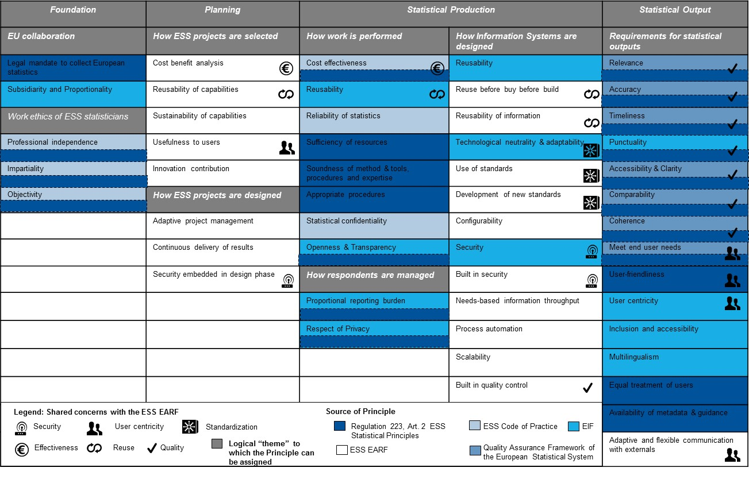

1. Overview ESS EARF Principles in relation to other Key Principles

Any questions regarding this   
should be addressed to:

Jean-Marc Museux

Enterprise Architect

Eurostat

Joseph Bech building

5 Rue Alphonse Weicker

L-2721 Luxembourg

Email: [Jean-Marc.Museux@ec.europa.eu](mailto:Jean-Marc.Museux@ec.europa.eu)

1. <http://pubs.opengroup.org/architecture/togaf8-doc/arch/chap29.html>
2. <http://unstats.un.org/unsd/dnss/gp/FP-New-E.pdf>
3. [http://unstats.un.org/unsd/methods/statorg/Principles_stat_activities/Principles_stat_activities.htm](http://unstats.un.org/unsd/methods/statorg/Principles_stat_activities/principles_stat_activities.htm)
4. <http://epp.eurostat.ec.europa.eu/portal/page/portal/product_details/publication?p_product_code=KS-32-11-955>
5. Regulation (EC) No 223/2009 of the European Parliament and of the Council of 11 March 2009 on European statistics and repealing Regulation (EC, Euratom) No 1101/2008 of the European Parliament and of the Council on the transmission of data subject to statistical confidentiality to the Statistical Office of the European Communities, Council Regulation (EC) No 322/97 on Community Statistics, and Council Decision 89/382/EEC, Euratom establishing a Committee on the Statistical Programmes of the European Communities (Text with relevance for the EEA and for Switzerland): <http://eur-lex.europa.eu/legal-content/EN/TXT/?uri=CELEX:32009R0223>
6. <http://ec.europa.eu/eurostat/documents/64157/4392716/ESS-QAF-V1-2final.pdf/bbf5970c-1adf-46c8-afc3-58ce177a0646>
7. <http://ec.europa.eu/isa/documents/isa_annex_ii_eif_en.pdf>
8. As stated in Table 8, the Project go-no go Principles can complement or be integrated in the list of go-no go criteria to be operationalized by the VIG.
9. <http://epp.eurostat.ec.europa.eu/portal/page/portal/product_details/publication?p_product_code=KS-32-11-955>
10. Regulation (EC) No 223/2009 of the European Parliament and of the Council of 11 March 2009 on European statistics and repealing Regulation (EC, Euratom) No 1101/2008 of the European Parliament and of the Council on the transmission of data subject to statistical confidentiality to the Statistical Office of the European Communities, Council Regulation (EC) No 322/97 on Community Statistics, and Council Decision 89/382/EEC, Euratom establishing a Committee on the Statistical Programmes of the European Communities (Text with relevance for the EEA and for Switzerland): <http://eur-lex.europa.eu/legal-content/EN/TXT/?uri=CELEX:32009R0223>
11. <http://ec.europa.eu/eurostat/documents/64157/4392716/ESS-QAF-V1-2final.pdf/bbf5970c-1adf-46c8-afc3-58ce177a0646>
12. <http://ec.europa.eu/isa/documents/isa_annex_ii_eif_en.pdf>