ESS Enterprise Architecture Reference Framework v1.1

**Artefact 1: Introductory document**

31 August 2017



Table of Contents

1.0 Establishing the ESS Enterprise Architecture Reference Framework to support the ESS Vision 2020 implementation 2

2.0 The frameworks the ESS EARF builds upon 2

3.0 The use cases for the ESS EARF 3

4.0 The main benefits of the ESS EARF 5

5.0 ESS EARF metamodel and artifacts 5

5.1 The ESS EARF metamodel 5

5.2 ESS EARF Artifacts 7

5.3 ESS EARF Supporting materials 8

5.4 The ESS EARF metamodel applied 8

6.0 Version history 9

7.0 The ESS EARF’s Governance 10

Annex: Glossary 11

1. Establishing the ESS Enterprise Architecture Reference Framework to support the ESS Vision 2020 implementation

The discipline of **Enterprise Architecture** aims to create an **organizational environment** which can **flexibly change** and thus dynamically **support** evolving **business goals**.

* It captures what the business needs are, where the organization wants to be, and ensures that the IT strategy aligns with this.
* It takes a holistic view on the organization, and helps remove silos between business units, improve their collaboration and standardization and ensure greater cost effectiveness of ICT investments.[1]

The document at hand introduces the **European Statistical System Enterprise Architecture Reference Framework** (ESS EARF) to support the implementation of the [ESS Vision 2020](https://ec.europa.eu/eurostat/web/ess/about-us/ess-vision-2020) on which the European Statistical System Committee agreed in May 2014 as the guiding frame for ESS developments up to 2020.

The ESS Vision 2020 has laid down the basis for cooperation in the ESS on modernizing the production and dissemination of ESS statistics and has outlined the future business strategy in response to a set of common challenges identified.

**The ESS Vision 2020 explicitly called for the establishment of an ESS Enterprise Architecture** as a Reference Framework by presenting the adoption of a “Common Reference Enterprise Architecture” as one of its implementation elements.

The ESS Vision 2020 describes Enterprise Architecture as “a systematic language to describe the way our business wants to operate and how the various components fit together. It serves to translate our vision into implementation strategies and priorities in a systematic way. It will be based on principles of standardization and interoperability, reuse, statistical subject matter domain-independent standard processes, metadata driven business chains and service-oriented data-based outputs of statistical processes.”[2]

1. The frameworks the ESS EARF builds upon

There has already been significant work on developing frameworks and standards relevant for the ESS Enterprise Architecture in other contexts. The ESS EARF therefore **draws on** and borrows as much as possible existing concepts and definitions from **established frameworks**.

The ESS EARF leverages the worldwide-used Open Group Enterprise Architecture Framework **TOGAF**[3] as a standard methodology for defining an Enterprise Architecture. It also utilizes the Open Group-developed **Archimate** Enterprise Architecture modeling language to support the description, analysis and visualization of architecture artifacts where possible.

The ESS EARF further builds on the standard frameworks for the official statistics industry: **GSBPM** (Version 5.0)[4], **GSIM** (Version 1.1)[5], **GAMSO** (Version 1.1)[6] and the **Common Statistical Production Architecture** (CSPA Version 1.3) developed by the High-Level Group for the Modernisation of Statistical Production and Services (HLG-MOS)[7].

The current version incorporates elements and concepts from the **EIRA**[8] (European Interoperability Reference Architecture). EIRA was developed within the remits of the **ISA2** (Interoperability solutions for public administrations, businesses and citizens) **programme**. It serves to ensure that ICT solutions in European public administrations are interoperable[9].

Whilst the ESS EARF is based on the above initiatives, its focus is by definition on developing an Enterprise Architecture that is specifically suitable for the ESS and the implemention of the ESS Vision 2020.

The ESS EARF intentially does not replicate the work accomplished by other ESS initiatives such as the ESS Security and Secure exchange of data Working Group, continuous work in the area of Quality Management in EU statistics and the ongoing Expert Group on Standardisation. A general consideration is that quality, security and standardization are transversal to all Enterprise Architecture deliverables and that the reader seeking further detail in these areas should consult the works of these ESS initiatives.

1. The use cases for the ESS EARF

The ESS EARF provides a set of artifacts[10] that support and guide stakeholders to meet business, information and technology requirements derived from the ESS Vision 2020 and support their implementation. It builds and incorporates the shared vision of how ESS member organizations will operate together. It is an essential a tool for aligning IT and business strategy and ensuring business value from information technology within the ESS.

* **Usage recommendation 1:** The ESS EARF is useful where decisions are to be made at **programme and project levels** about the **design** and **selection** of ESS projects as well as the **implementation** of business processes and the supporting information systems **under the remit of the ESS**.
* **Usage recommendation 2:** The ESS EARF is useful to **all ESS member organizations** in their adoption of the new ESS cooperation model.
* **Usage recommendation 3:** The ESS EARF is useful to **multiple audiences**: ESS governance, senior (business and IT) managers, enterprise architects, solution architects, project managers.

What follows is an illustrative list of use cases for the ESS EARF.

|  |  |
| --- | --- |
| **Audience** | **Ilustration of Use case** |
| Usage by ESS governance | * Members of the ESS Governance safeguard the adherence to the ESS EARF as an assurance for sustainable, efficient and reusable ICT developments. * They ensure that the ESS EARF is used to inform and guide the acceptance or prioritization of ESS projects and their adaptation. * To make use of the most appropriate level of expertise, they request the opinion of the ESS EA board[11] on whether the ESS EARF is adequately being followed or not. |
| Usage by ESS Business Leaders | * Business leaders leverage the ESS EARF as a means to bridge IT and business perspectives and to more systematically and comprehensively discuss their priorities with IT. * They leverage the ESS EARF to ensure there is alignment between business objectives and IT constraints e.g. to reduce cost and shorten development cycles by limiting specific, tailor-made developments and implementations and standardizing and reusing existing components across statistical processes, products and projects. |
| Usage by ESS IT Leaders  C:\Users\blorincz\Documents\Collab BM TAXUD\Benchmark\shadow of face.jpg | * IT Leaders use the ESS EARF as a key reference to design and describe both ESS-specific and NSI-internal IT developments. * They use it to better align architectures and investments amongst ESS members, enabling greater efficiency and effectiveness within the ESS. * They leverage the ESS EARF to ensure the IT projects they are in charge of contribute to the realization of ESS Vision 2020. |
| Usage by ESS Enterprise architects  http://www.clker.com/cliparts/5/2/q/K/V/H/teacher-hi.png | * EA functions in ESS member organizations use the ESS EARF to map the architectures and projects of their own organizations, especially when these have a pan-European dimension and have a potential of reuse across borders. * When engaged in ESS projects, they use the ESS EARF to head-start their efforts to ensure the solutions are designed in a sustainable, coherent and interoperable way. |
| Usage by ESS projects | * ESS projects use the ESS EARF for the design of their project-specific architectures.   + - They use it to ensure their projects are developed faster and in line with ESS vision objectives and priorities.     - The ESS EARF helps them identify components available for reuse and create reusable components for others. |

Table Use cases for the ESS EARF

1. The main benefits of the ESS EARF

The ESS EARF is meant to support the achievement of the goals set out in the ESS Vision 2020. If the ESS EARF is used in the ESS as a basis for architectural (re)-design, this can generate a number of benefits to ESS participants and ESS member organizations.

Depending on the focus area of the (re)-design, these would include:

* **Cost savings** through reuse and sharing of services and infrastructure where appropriate, reducing both capital investments and operating cost
* Gradual **breakdown of** organizational **silos** through deployment of components across statistical subject matter domains, statistical phases and process steps and/or across countries. Statisticians within the ESS would increasingly collaborate and make mutual use of expertise, methodologies and services
* **Streamlined** and more standardized **processes** through ensuring that statistical process steps (e.g. within the validation phase) are harmonized and not redundant within the ESS
* **Better services** through specialization, whereby some ESS participants could focus on certain aspects of statistics (e.g. the design of collection instruments), accelerating and deepening the creation of expertise
* Higher **business agility** by re-using services. By re-using services within the ESS, ESS members increase the possibility of reacting faster to new requirements.

1. ESS EARF metamodel and artifacts
   1. The ESS EARF metamodel

Figure 1 presents the metamodel[12][13]underlying the ESS EARF. The metamodel depicts:

* **what ESS EARF artifacts** are available,
* and the **type of work they support** in the ESS.

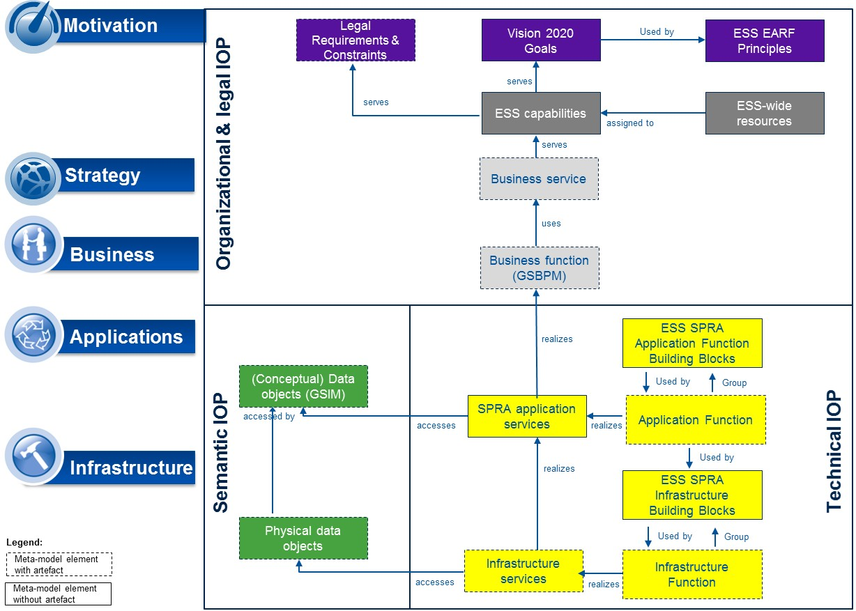

1. ESS EARF metamodel

As shown in the top left corner of the metamodel, the context within which collaboration in the ESS takes place and the commitments ESS member organizations have made to work together are defined in the various **legal acts** relating to pan-European statistical production, in particular REGULATION (EC) No 223/2009 OF THE EUROPEAN PARLIAMENT AND OF THE COUNCIL of 11 March 2009 on European statistics[14].

The **ESS Vision 2020** specifies further the joint objectives for ESS member organizations and forms the starting point for all activities implementing the ESS.

The ESS EARF artefact **ESS Capabilities** articulates the organization, people, processes, and technology required in the ESS to implement the Vision, thus providing priority areas of work to which **ESS resources** could be assigned to ensure the objectives and challenges identified in the ESS Vision 2020 can indeed be met.

The ESS EARF artefact **ESS EARF Principles** can help guide key decisions on ESS projects as regards which projects to pursue, how to set them up and how to design the information systems in support of them.

Together, these various documents provide for robust directional guidance as to how the ESS shall get implemented.

Strategic and business leadership considerations in the ESS include a detailing of **Business services** and **Business Functions** required to deliver high quality statistical outputs and adding value to each step in the statistical production chain.Such considerations are thoroughly addressed in other works (notably GSBPM, ESS member organizations’ business strategies, as well as ESS projects’ business plans) and hence are out of scope of the ESS EARF artifacts.

The bottom left-hand side of the framework makes reference to the **conceptual** and **physical data elements** utilized in the ESS. Conceptual aspects of data are already deeply addressed in GSIM and hence are out-of-scope of the ESS EARF artifacts. Aspects of data architecture in general are not in scope of this version of the ESS EARF.

Rather, the ESS EARF focuses on the **Application** and **Infrastructure functions** that are required to successfully implement the ESS Vision 2020. The artefact ESS EARF Statistical Production Reference Architecture (**ESS EARF SPRA** – see also further below) in this sense provides the main **ESS SPRA Application Function Building Blocks, ESS SPRA Infrastructure Building Blocks** and **ESS SPRA application services** that will provide the required IT-enabled functionalities so ESS stakeholders have the appropriate ICT infrastructure and IT tools in place to work efficiently and effectively in the ESS.

* 1. ESS EARF Artifacts

In reflection of the metamodel, the ESS EARF includes the following artefacts:

1. **Artefact 1: Introductory document[15]**
2. **Artefact 2: ESS EARF Principles**
3. **Artefact 3: ESS capabilities**
4. **Artefact 4: ESS Statistical Production Architecture (ESS SPRA)** which includes
   1. **Artefact 4a:** the relevant **ESS Application and Infrastructure Building Blocks** and
   2. **Artefact 4b: ESS Application Services**
   3. **Artefact 4c: Guide to SPRA Archimate models**
   4. **Artefact 4d: SPRA Archimate models**
5. **Artefact 5: ESS EARF Glossary**
   1. ESS EARF Supporting materials

The ESS EARF also includes the following supporting materials (templates and toolkits) that are available to ESS member organizations to better leverage the ESS EARF artifacts:

1. **Artefact 6: Toolkit: Defining your project’s Business Architecture based on the ESS EARF**
2. **Artefact 7: Template for ESS EARF Compliance review** 
   1. The ESS EARF metamodel applied

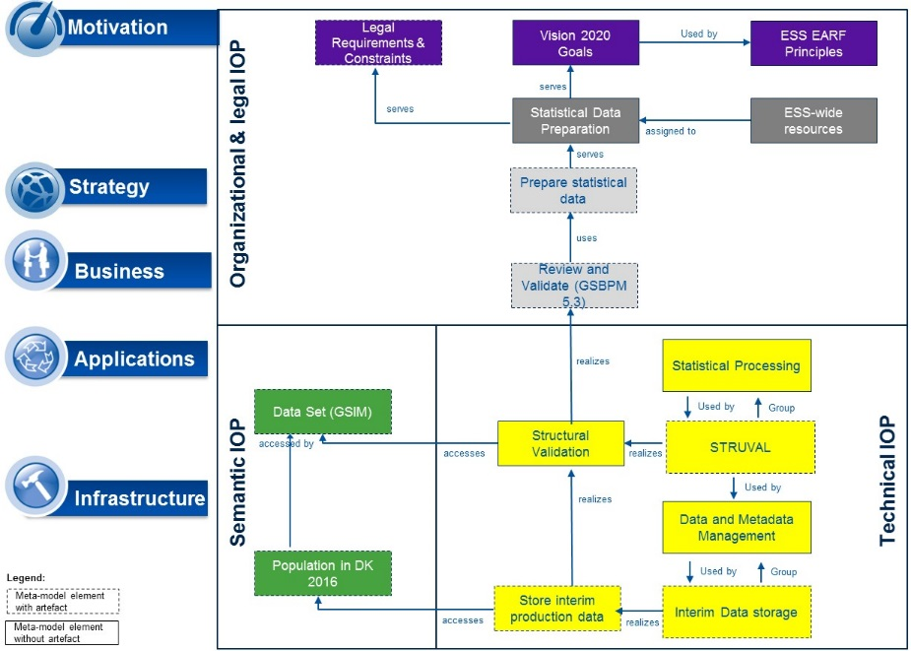Figure 2 in a simplified way depicts how the various ESS EARF and SPRA artifacts can contribute to more efficiently and effectively designing and implementing an ESS statistical production activity (example: Validation).

The ESS capability model allows to identify and describe the ESS capability that is being focused on, which is “Statistical Data Preparation”. More specifically, the Validation project will help improve the implementation of Validation in support of the GSBPM sub-process 5.3[16].

1. ESS EARF metamodel illustration for Validation

Two ESS SPRA Building Blocks are to be (if already available) or will need to be (if there is a need to configure, procure or build them) utilized: the Application Function Building Block “Statistical Processing” and the Infrastructure Building Block “ Data and Metadata Management”. These Building Blocks will support the realization of the SPRA Application service “Structural Validation” that will provide the required Validation functionalities to statisticians across ESS member organizations.

The ESS staff working on the Validation project could leverage the Toolkit “Defining your project’s Business Architecture based on the ESS EARF” to ensure a faster and more Vision 2020-aligned design of its project. The: ESS Enterprise Architecture Board (see 1.7) may use the “Template for ESS EARF Compliance review” when reviewing the ESS Validation project.

1. Version history

The ESS EARF is a joint work of the ESS member organizations carried out **under** the responsibility of the ESS Governance Group Directors of Methodology **DIME/ITDG[17]**. The DIME/ITDG had set up an ESS EA Task Force to develop the ESS EARF. This Task Force brought together Architecture experts from 9 NSIs[18] who collaborated intensively under Eurostat coordination and chairmanship to establish and finalize the ESS EARF. Following this collaboration, **Version 1.0 of the ESS EARF** was released on 31 August 2015 as baseline reference architecture framework in the ESS.

**Version 1.1** is the current release. The main modifications compared to Version 1.0 are:

* Alignment with the European Commission (ISA2) European Interoperability Framework and European Interoperability Reference Architecture
* Splitting of the ESS EARF v1.0 consolidated document into detachable, i.e. separately usable and manage-able artifacts
* The ESS SPRA has been tested with a number of ESS projects[19], which has led to a revision and the publication of the ESS SPRA as a model in Archi.

The **ESS EARF supporting materials** are thus all in their **version 1.0** at this moment.

Table 1 summarizes the ESS EARF artifact’s version history.

|  |  |  |
| --- | --- | --- |
| **ESS EARF version** | **ESS EARF artifact version** | **Date** |
| **ESS EARF v1.0** | The ESS EARF v1.0 was provided as a single document, comprised of the following chapters:   * 1.0 Introduction to the ESS EA Reference Framework * 2.0 The ESS Business Capabilities model * 3.0 The ESS EARF Building Blocks and Standards * 5.0 Statistical production reference architecture (SPRA) * Annex: Glossary | 31 August 2015 |
| **ESS EARF v1.1** | The ESS EARF v1.1 consists of the following set of detachable artifacts:   * Artefact 1: Introductory document * Artefact 2: ESS EARF Principles * Artefact 3: ESS capabilities * Artefact 4: ESS Statistical Production Architecture (ESS SPRA) including   + - Artefact 4a: ESS Application and Infrastructure Building Blocks and     - Artefact 4b: ESS Application Services     - Artefact 4c: Guide to SPRA Archimate models     - Artefact 4d: SPRA Archimate models * Artefact 5: ESS EARF Glossary | 31 August 2017 |
| **ESS EARF Supporting materials v1.0** | * Artefact 6: Toolkit: Defining your project’s Business Architecture based on the ESS EARF * Artefact 7: Template for ESS EARF Compliance review | 31 August 2017 |

1. Version history of ESS EARF and ESS EARF artifacts
2. The ESS EARF’s Governance

Based on a mandate by the DIME/ITDG, the **ESS Enterprise Architecture Board** (ESS EAB) was created as a permanent Governance body in March 2016 as part of the ESS Vision 2020 implementing framework activities .

The ESS EAB, based on the ESS EARF:

* Organizes and assesses the EA reviews of ESS.VIP projects ensuring that they are aligned with the ESS EA and the ESS Vision 2020 and that existing standards are properly used
* Provides a forum for exchange of views in the areas related to ESS Enterprise Architecture, identifying the need for change and validating the future versions of the ESS Enterprise Architecture Reference Framework and managing its relations with other industry frameworks
* Facilitates the capacity building and knowledge management in the areas under its responsibility (Business, Information, Application and overall Enterprise Architecture)
* Facilitates and promotes the use of Enterprise Architecture in the ESS

The ESS EAB reports directly to the DIME/ITDG. The continuation of the body will be decided upon in 2020, together with a potential re-scoping of its responsibilities, should new or different interventions be more appropriate.

# Annex: Glossary

|  |  |
| --- | --- |
| Term | Definition |
| ESS EARF Business Capability Model related | |
| Business Capability | A Business Capability can be defined as "an ability that an organization, person, or system possesses. Capabilities are typically expressed in general and high-level terms and typically require a combination of organization, people, processes, and technology to achieve.” [20] |
| Business Capabilities Modeling | Business Capabilities Modeling is a technique for representing an organization's business, independent of organization structure, processes, people or business functions.[21] |
| ESS EARF Building Block related | |
| Building Block | The ESS EARF defines a set of Building Blocks (BBs) which represent (potentially re-usable) components of (IT) capability.  According to TOGAF, a BB has the following characteristics: it evolves such so as to exploit new technologies and standards; it may be assembled from other BBs, or may be a subassembly of other BBs; it is re-usable and replaceable, and well specified. |
| ESS Standard | An ESS Standard is a normative document, established by consensus among ESS members and approved by a recognised body according to the procedure of ESS standardisation, that provides for common and repeated use by several actors in the ESS, rules, guidelines or characteristics for the development, production and dissemination of European Statistics, aimed at the achievement of the optimum degree of order in the context of the implementation of the mission and vision of the ESS. |
| ESS EARF Principles related | |
| Principle | Principles are **general rules** and guidelines, intended to be enduring and seldom amended, that inform and support the way in which an organization sets about fulfilling its mission.[22] |
| Information/Data related | |
| Microdata | Microdata are defined as an observation data collected on an individual object i.e. statistical unit. [23] |
| Macrodata | Macrodata are defined as an observation data gained by a purposeful aggregation of statistical microdata conforming to statistical methodology. [24] |
| Metadata | Metadata is data that defines and describes other data.[25] |
| Active metadata | Active metadata are metadata that are structured and accessible in a way that they are used as parameters for computer programs. The possibility of “activation” of metadata requires a sufficient level of structuration of metadata. |
| Passive metadata | Passive metadata are metadata that are not active, typically consisting of human-readable documentation or reports. Passive metadata can be generated both manually and through the use of computer programs. |
| Structural metadata | Structural metadata act as identifiers and descriptors of the data. Structural metadata are needed to identify, use, and process data matrixes and data cubes (e.g. names of datasets, columns or measure/dimensions of statistical cubes, code lists). |
| Reference metadata | Reference metadata describe the contents and the quality of the statistical data. This may include conceptual, methodological or quality metadata (e.g. populations, questionnaires, sample design, imputation rates). |
| Process metadata | Process metadata describe the processes that created and delivered the data. (e.g. process models, process implementations, processing and validation rules, process metrics). |
| Business Architecture related | |
| Business Architecture | According to TOGAF, the Business Architecture “describes the product and/or service strategy, and the organizational, functional, process, information, and geographic aspects of the business environment”.[26] |

Any questions regarding this Report  
should be addressed to:

Jean-Marc Museux

Chief Enterprise Architect

Eurostat

Joseph Bech building

5 Rue Alphonse Weicker

L-2721 Luxembourg

Email: ESTAT-EA@ec.europa.eu

1. Based on common Statistical Production Architecture, UNECE: http://www1.unece.org/stat/platform/display/CSPA/CSPA+v1.1
2. Excerpt from ESS Vision 2020
3. http://www.opengroup.org/standards/ea
4. http://www1.unece.org/stat/platform/display/GSBPM/GSBPM+v5.0
5. http://www1.unece.org/stat/platform/display/gsim/GSIM+Specification
6. http://www1.unece.org/stat/platform/display/GAMSO/GAMSO+v1.0
7. http://www1.unece.org/stat/platform/display/hlgbas/High-Level+Group+for+the+Modernisation+of+Statistical+Production+and+Services
8. https://joinup.ec.europa.eu/asset/eia/description
9. Interoperability can be defined as the ability of organizations to interact towards mutually beneficial goals, involving the sharing of information and knowledge between these, through the business processes they support, by means of the exchange of data between their ICT systems. http://eur-lex.europa.eu/resource.html?uri=cellar:2c2f2554-0faf-11e7-8a35-01aa75ed71a1.0017.02/DOC_3&format=PDF
10. (i.e. architectural work products that describe an aspect of the architecture) http://pubs.opengroup.org/architecture/togaf9-doc/arch/chap02.html#tag_02_05
11. See section 1.7
12. A model that describes how and with what the architecture will be described in a structured way. http://pubs.opengroup.org/architecture/togaf9-doc/arch/chap03.html
13. The framework’s horizontal segments (motivation, strategy, business, application and infrastructure) are based on the “Full framework” for the Archimate modeling language. This segmention is an indication for what type of work the ESS EARF and SPRA artifacts are supportive of (from motivation and strategy definition to technical implementation), see <http://pubs.opengroup.org/architecture/archimate3-doc/chap03.html#_Toc489945971>. The three interoperability groups (organizational & legal, semantic and technical interoperability) are based on the levels of interoperability considered vital in pan-European collaboration between public authorities, as defined in the European Interoperability Framework, see <https://ec.europa.eu/isa2/eif_en>.
14. http://ec.europa.eu/eurostat/documents/34693/344802/Regulation-on-European-Statistics-11-03-2009
15. (the document at hand)
16. https://statswiki.unece.org/display/GSBPM/V._+Descriptions+of+Phases+and+Sub-processes
17. https://ec.europa.eu/eurostat/cros/content/dimeitdg-governance_en
18. Austria, France, Italy, Norway, The Netherlands, Slovenia, Switzerland, United Kingdom, Sweden
19. ESBRs, Validation, complete list#
20. TOGAF
21. Gartner
22. <http://pubs.opengroup.org/architecture/togaf8-doc/arch/chap29.html>
23. https://stats.oecd.org/glossary/detail.asp?ID=1656
24. https://stats.oecd.org/glossary/detail.asp?ID=1574
25. https://stats.oecd.org/glossary/detail.asp?ID=5136
26. http://pubs.opengroup.org/architecture/togaf9-doc/arch/chap08.html