**Artifact 7: Template for ESS EARF Compliance review**

31 August

Version 1.0



Table of Contents

About this document 2

ESS EARF compliance review 3

1.0 ESS Business Capabilities Model 4

2.0 SPRA Building Blocks, Services and Standards 6

3.0 ESS EARF Principles 8

4.0 ESS EARF Glossary 10

5.0 ESS EA interaction 11

6.0 Overall assessment 12

# About this document

This document should support a systematic, structured review of ESS projects against the ESS Enterprise Architecture Reference Framework (EARF) and Statistical Production Architecture (SPRA).

The metamodel of the EARF is presented in the figure below.

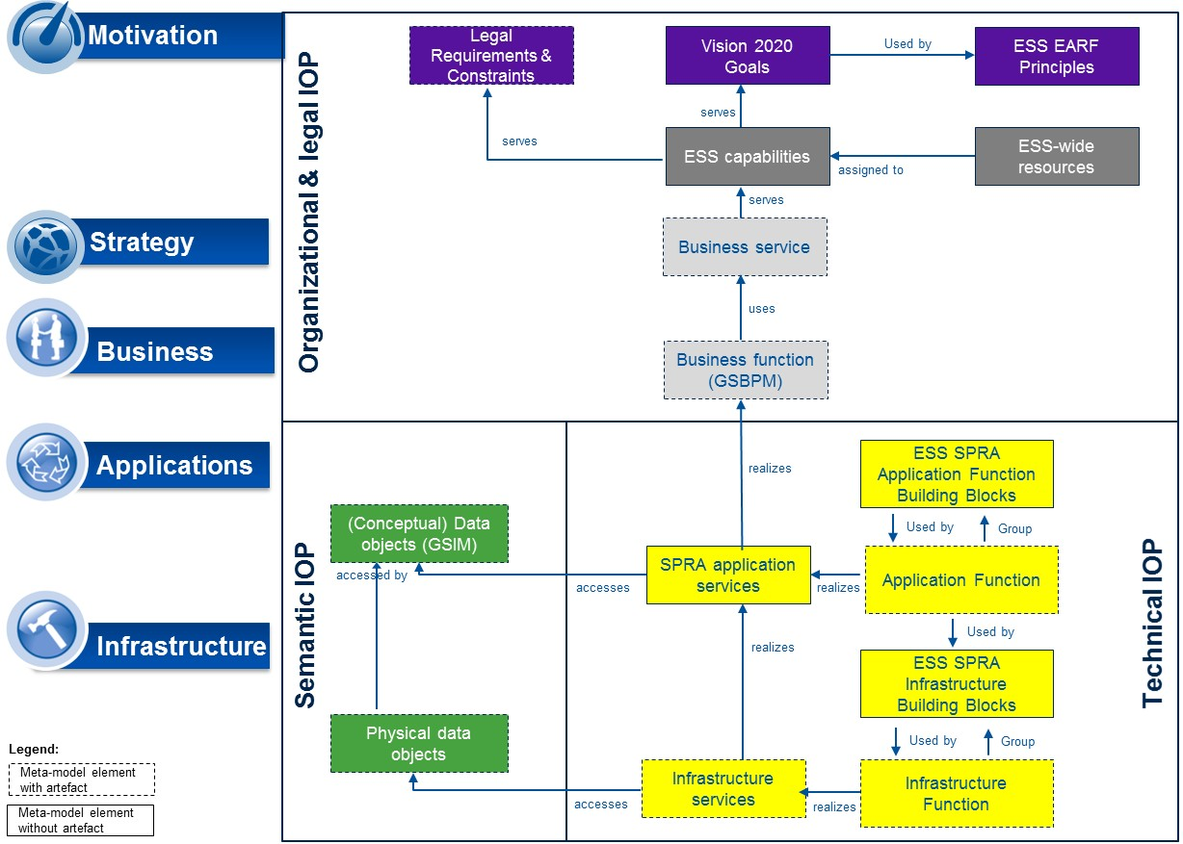

1. The ESS EARF Metamodel

Audience are thus EA experts in charge of such reviews. The template comprises the key criteria against which the assessment should take place as well as the required evaluation grids and forms.

The review template is inspired by TOGAF, a worldwide recognized Enterprise Architecture Development Method.

# ESS EARF compliance review

1. ESS Business Capabilities Model

|  |  |  |
| --- | --- | --- |
| **Criterion** | **Score[1]** | **Reviewer comments** |
| ***Procedural compliance*** | | |
| The project documents the Business Capabilities affected by the project. |  |  |
| The project models its Business Capabilities using the ESS Business Capability Modeling toolkit |  |  |
| The project uses the Business Capabilities Model to communicate with project-internal and external stakeholders |  |  |
| ***Content compliance*** | | |
| The project derives the capabilities relevant in the project from those identified in the ESS EARF |  |  |
| The project has aligned its definitions of capabilities to those of the ESS EARF |  |  |
| ***Content completeness*** | | |
| The project breaks down the high-level capabilities of the ESS EARF into sufficient level of detail (level 3 and beyond) |  |  |
| The project breaks down its capabilities into their six components: organization, people, processes, IT, standards and method |  |  |
| The project maps where the capabilities reside among ESS partners: ESTAT versus NSIs |  |  |
| Project capabilities are related to clear deliverables and timelines |  |  |
| ***Compliance outcomes*** | | |
| The project improves key capabilities for the ESS |  |  |
| The project creates capabilities reusable within the ESS |  |  |
| * Business Capabilities |  |  |
| * Data |  |  |
| * Technical Capabilities |  |  |
| The project reuses capabilities from other ESS projects |  |  |
| * Business Capabilities |  |  |
| * Data |  |  |
| * Technical Capabilities |  |  |
| Average score[2] |  | |
| Reviewer comments |  | |

1. SPRA Building Blocks, Services and Standards

|  |  |  |
| --- | --- | --- |
| **Criterion** | **Score[3]** | **Reviewer comments** |
| ***Procedural compliance*** | | |
| The project models Building Blocks |  |  |
| The project models Business services |  |  |
| The project defines which (organizational, technical and semantic) standards it will be adhering to |  |  |
| The project uses the ESS Building Block and Services toolkit |  |  |
| The project documents its contributions to ESS Building Blocks and Business services in the Global catalogue (alternatively with the EA team) |  |  |
| ***Content compliance*** | | |
| The project Building Blocks are derived from the ESS Building Blocks and the relationship is explicitly mapped |  |  |
| The services established by the project are derived from the ESS Business services and the relationship is explicitly mapped |  |  |
| ***Content completeness*** | | |
| The project reuses all ESS Building Blocks feasible for reuse |  |  |
| The project has explored the reuse of ESS services feasible for reuse |  |  |
| The project details its federation approaches: autonomous, interoperable, replicated or shared |  |  |
| The project specifies one/more realistic implementation options for the realization of the building blocks |  |  |
| The project contributes to refining the ESS Building Blocks and Business services |  |  |
| The project contributes to enriching the list of ESS standard IT solution building blocks |  |  |
| ***Compliance outcomes*** | | |
| The project complies with the ESS (organizational, technical and semantic) standards[4]. Deviations or the adherence to additional standards are duly justified |  |  |
| The project actively reuses Building Blocks and Business services already available for reuse from other ESS projects |  |  |
| The project reuses the standard IT solution building blocks listed in the ESS EARF |  |  |
| The project implements (parts of) the ESS Building Blocks |  |  |
| The project implements Building Blocks in line with the suggested target federation model (e.g. the ESS EARF stipulating a shared implementation) |  |  |
| The project makes generic services available for reuse |  |  |
| The project specifies financing and governance mechanisms for implementing the Building Blocks and services in an efficient and effective manner |  |  |
| Project members use the concepts of Building Blocks, Business services and standards to design, revise and compare their MS-internal reference architectures |  |  |
| The Building Block, Business services and standard views are used to rationalize the existing IT portfolios impacted by the project |  |  |
| The project actively uses the Building Block, Services and Standard approach to identify synergies, redundancies, and conflicts with other ESS projects |  |  |
| Average score[5] |  | |
| Reviewer comments |  | |

1. ESS EARF Principles

|  |  |  |
| --- | --- | --- |
| **Criterion** | **Score[6]** | **Reviewer comments** |
| ***Procedural compliance*** | | |
| The project has explicitly considered principles for the project |  |  |
| The project uses the ESS Principles toolkit |  |  |
| The project’s principles are endorsed by project participants |  |  |
| The project’s principles are formally endorsed by senior leaders |  |  |
| The principles are actively used as reference points in discussions with project-internal and external stakeholders |  |  |
| ***Content compliance*** | | |
| The project’s principles have been derived from the ESS EARF and do not conflict with the EARF principles |  |  |
| ***Content completeness*** | | |
| The project anticipates decision-making situations in which principles will serve to guide the decisions |  |  |
| The principles are articulated in terms of their name, statement, rationale and implications |  |  |
| ***Compliance outcomes*** | | |
| *Compliance with project go-no go principles[7]* | | |
| -cost-benefit analysis |  |  |
| -reusable capabilities |  |  |
| -sustainable capabilities |  |  |
| -innovation |  |  |
| -product usefulness |  |  |
| *Compliance with project design criteria[8]* | | |
| -adaptive project management |  |  |
| -continuous delivery of outputs/comes |  |  |
| -security by design |  |  |
| *Information system architecture[9]* | | |
| -needs-based throughput |  |  |
| -reuse of information |  |  |
| -adaptive, flexible communication |  |  |
| -configurable process and systems |  |  |
| -automated processes |  |  |
| -use of existing standards |  |  |
| -development of new standards |  |  |
| -reuse before buy and build |  |  |
| -scalability |  |  |
| -built-in security |  |  |
| -built-in quality control |  |  |
| Average score[10] |  | |
| Reviewer comments |  | |

1. ESS EARF Glossary

|  |  |  |
| --- | --- | --- |
| **Criterion** | **Score[11]** | **Reviewer comments** |
| ***Content compliance*** | | |
| The project’s terminology complies with the ESS EARF Glossary |  |  |
| ***Content completeness*** | | |
| The project contributes to enriching the ESS EARF Glossary (or other relevant glossaries) |  |  |
| Average score[12] |  | |
| Reviewer comments |  | |

1. ESS EA interaction

|  |  |  |
| --- | --- | --- |
| **Criterion** | **Score[13]** | **Reviewer comments** |
| The project has involved the ESS EA team early on for support |  |  |
| The project continuously gathers feedback from the ESS EA team |  |  |
| The project continuously collaborates with the ESS EA team, going beyond feedback |  |  |

1. Overall assessment

|  |  |  |
| --- | --- | --- |
| **Reviewer:** | | |
| **Date:** | | |
| **Evaluation sub-scores** | | |
| Business Capability Model |  | |
| Building Blocks, Services and Standards |  | |
| Principles |  | |
| Information view | |  |
| Glossary | |  |
| ESS EA interaction | |  |
| **Reviewer Analysis** | | |
| Overall Rating[14] | | *Notes*  Rating of 1 implies “Inconsistency with ESS EARF and ESS SPRA”:  Only few features of the project are in accordance with the ESS architecture reference materials.  Rating of 2 means “Basic compliance with ESS EARF and ESS SPRA”:  The project adopts some features of the ESS EA reference frames. However, there remains additional alignment work to accomplish.  Rating of 3 implies: “State-of –the-art compliance with the ESS EARF and ESS SPRA”  There is very strong correspondence between the project specification and the ESS EA reference materials. The project can be qualified as good practice and should be used as leading example in communications with other ESS projects and senior management. |
| Overall analysis | | *Notes*  Free text format. Please be clear in terms of achievements, opportunities, weaknesses and risks for the project stemming from non/alignment with the ESS EA reference materials. Please in particular focus on business outcomes which are at stake. |
| Required improvement steps | |  |
| Additional review plans | |  |

Any questions regarding this   
should be addressed to:

Jean-Marc Museux

Enterprise Architect

Eurostat

Joseph Bech building

5 Rue Alphonse Weicker

L-2721 Luxembourg

Email: [Jean-Marc.Museux@ec.europa.eu](mailto:Jean-Marc.Museux@ec.europa.eu)

1. Score from 1 to 3 (low to high), with 3 being the highest achievable score. Where a criterion is not applicable, please insert “NA”.
2. Please calculate the average, disregarding all “NA” fields.
3. Score from 1 to 3 (low to high), with 3 being the highest achievable score. Where a criterion is not applicable, please insert “NA”.
4. [Catalogue of ESS Standards](http://ec.europa.eu/eurostat/ramon/nomenclatures/index.cfm?TargetUrl=LST_NOM_DTL&StrNom=CAT_STAND&StrLanguageCode=EN&IntPcKey=&StrLayoutCode=HIERARCHIC)
5. Please calculate the average, disregarding all “NA” fields.
6. Score from 1 to 3 (low to high), with 3 being the highest achievable score. Where a criterion is not applicable, please insert “NA”.
7. See ESS EARF
8. See ESS EARF
9. See ESS EARF
10. Please calculate the average, disregarding all “NA” fields.
11. Score from 1 to 3 (low to high), with 3 being the highest achievable score. Where a criterion is not applicable, please insert “NA”.
12. Please calculate the average, disregarding all “NA” fields.
13. Score from 1 to 3 (low to high), with 3 being the highest achievable score. Where a criterion is not applicable, please insert “NA”.
14. Please calculate the average of the 5 sub-scores above and round the number up or down