CAMSSaaS Service Request Acceptance Note v1.1.0

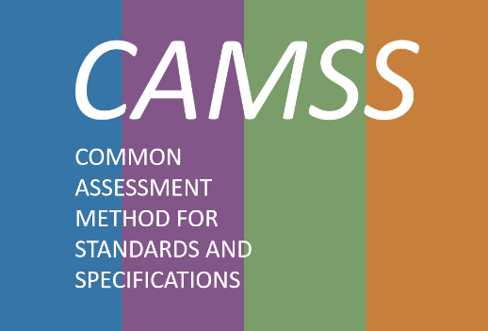

**Change Control**

|  |  |
| --- | --- |
| **Modification** | **Details** |
| **Version 1.1.0** | |
| **Current version** | * Addition of the CAMSSaaS modalities   + CAMSSaaS Assessment   + CAMSSaaS Content review   + CAMSSaaS Compliance review |
| **Version 1.0.0** | |
| **Initial version** |  |

**DISCLAIMERS:**

|  |
| --- |
| (*)By no means will CAMSS assessment imply any endorsement of the EC to the assessed specification. |

TABLE OF CONTENTS

1. Information on the request 4

2. Relevance criteria 5

TABLE OF TABLES

Table 1: Information on the request 4

Table 2: Relevance criteria 5

# Information on the request

|  |  |  |
| --- | --- | --- |
| **1** | **Title of the specification** |  |
| **2** | **Address where the version of the specification can be obtained/downloaded** |  |
| **3** | **Name, identifier and website of the standard developing organisation (SDO) of the specification** |  |
| **4** | **Contact information / contact person (including email address and phone number)**  **a.) for the organisation (optional)**  **b.) for the specification submitted (optional)** |  |
| **5** | **Describe the reason for the submission, the need and intended use for the specification** |  |
| **11** | **CAMSSaaS modality requested:**   * **CAMSSaaS Assessment** * **CAMSSaaS Content Review** * **CAMSSaaS Compliance Review** |  |

Table 1: Information on the request

# Relevance criteria

The specification (name of the technical specification) has been considered relevant enough by the CAMSS Team to carry out its assessment through the use of CAMSS Tools. The following criteria, belonging to the CAMSS Tools, justify this fact:

|  |  |  |
| --- | --- | --- |
|  | **Criteria** | **Score** |
| **1** | **The technical specification or standard addresses and facilitates interoperability between public administrations** |  |
| **2** | **The adoption of the technical specification or standard positively impacts on one or several of the following: organizational processes; the environment; the administrative burden; the disability support; cross-border services, public policy objectives and societal needs** |  |
| **3** | **The technical specification or standard addresses, facilitates or is an enabler of eGovernment** |  |
| **4** | **The functional and non-functional requirements for the use and implementation of the technical specification or standard are clearly defined** |  |
| **5** | **The technical specification or standard is applicable and extensible for implementations in different domains** |  |
| **6** | **The technical specification or standard provides added value compared to alternative technical specifications or standards in the same area of application** |  |
| **7** | **The technical specification or standard is largely compatible with related (not alternative) technical specification or standards in the same area of application?** |  |
| **8** | **There is evidence that the adoption of the technical specification or standard makes it easier to migrate between different solutions from different providers** |  |
| **9** | **There is evidence that the adoption of the technical specification or standard positively impacts the financial costs** |  |
| **10** | **There is evidence that the adoption of the technical specification or standard positively impacts any aspect of the security (e.g. data integrity, data authenticity, data transmission or communications, data preservation, cyber threats, penetration, any other aspect related to the security of the information system or interoperability)** |  |
| **11** | **There is evidence that the adoption of the technical specification or standard positively impacts the data or privacy protection** |  |
| **12** | **The risks related to the adoption of the technical specification or standard are acceptable** |  |

Table 2: Relevance criteria