CAMSSaaS Service Delivery Acceptance Note v1.1.0

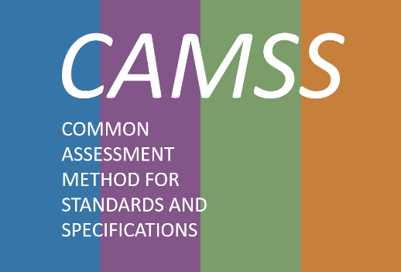

**Change Control**

|  |  |
| --- | --- |
| **Modification** | **Details** |
| **Version 1.1.0** | |
| **Current version** | * Addition of the disclaimer for the delivery of the CAMSS Assessment Summary to depend on the CAMSSaaS modality chosen by the User. |
| **Version 1.0.0** | |
| **Initial version** |  |

**DISCLAIMERS:**

|  |
| --- |
| (*)By no means will CAMSS assessment imply any endorsement of the EC to the assessed specification. |

|  |
| --- |
| (*)The CAMSS Assessment Summary will only be delivered in the context of CAMSSaaS Assessment and CAMSSaaS Content Review. |

TABLE OF CONTENTS

1. CAMSS Assessment 4

2. CAMSS Assessment Summary 4

3. Satisfaction survey 4

# CAMSS Assessment

# CAMSS Assessment Summary

# Satisfaction survey

In order fulfil CAMSSaaS Satisfaction Survey please access the address below:

<https://ec.europa.eu/eusurvey/runner/CAMSSaaSSatisfactionSurvey>