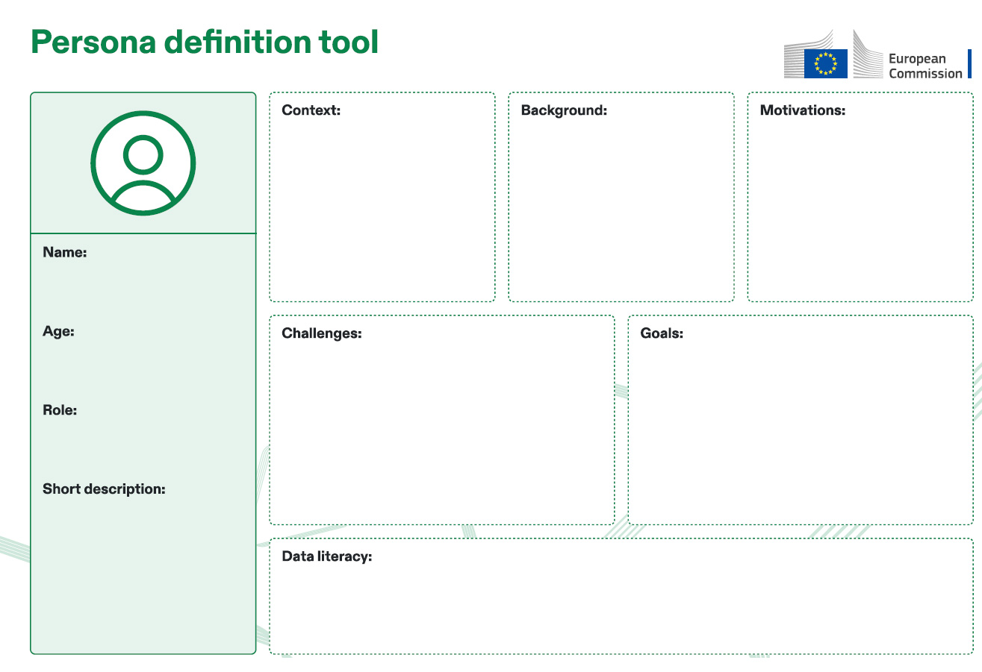

Outline the persona's objectives or what they aim to achieve to align

strategies with their ambitions and expectations.

Identify common pain points or obstacles they face (e.g., struggles

with fragmented data systems).

Use a realistic name for the persona (e.g.,

John Smith, Sara Lee) to humanise the

profile and make it relatable.

Specify the persona's age.

Define the persona's job title or primary

role.

Offer a concise summary highlighting the

persona's key attributes and

characteristics.

Identify what drives the persona, such as

their needs, desires, and aspirations, to

comprehend their actions and decisions.

Detail the persona's personal history,

including education and experiences, to

add depth and realism to their profile.

Describe the environment or

circumstances in which the persona

operates to grasp their situation and

challenges.

Describe their attitudes toward data and their technical proficiency.