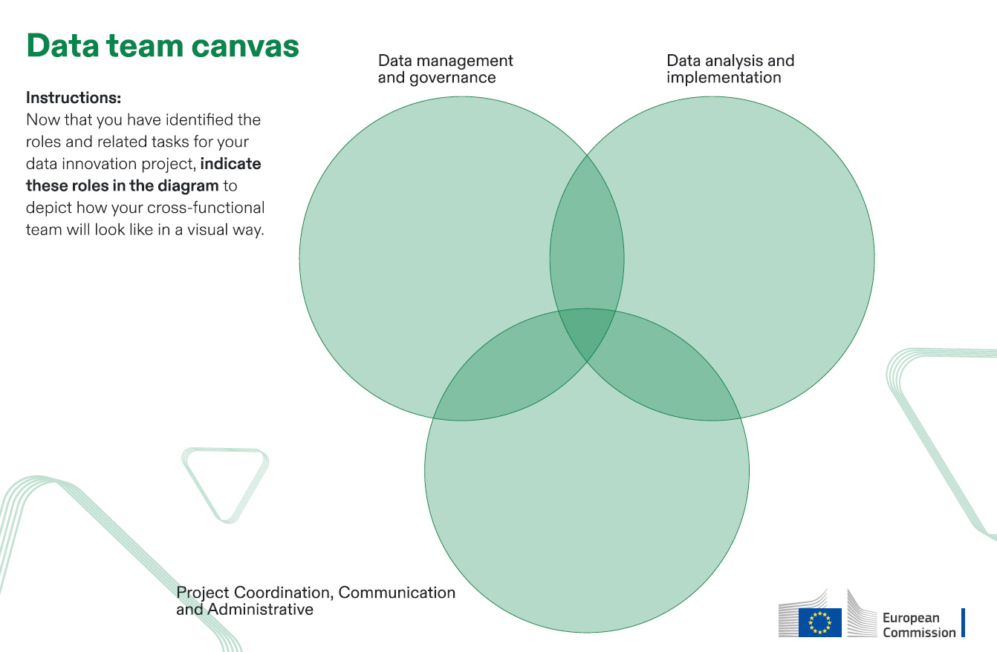

**Project manager:** Coordinates the data innovation project, ensuring alignment with organizational goals and EU regulations.

**IT infrastructure engineer:** Ensures the technical infrastructure is robust, secure, and compliant with EU regulations.

**Communications officer:** Manages communication strategies, ensuring clear and consistent messaging across all stakeholders.

**Financial manager:** Manages the budgeting and financial aspects of the project, ensuring compliance with EU financial regulations.

**Data scientist:** Analyses datasets to extract insights, develop models, and support data-driven decisions.

**Data analyst:** Interprets data to generate insights, creating reports and dashboards for stakeholders.

**Machine learning engineer:** Develops and deploys machine learning models, ensuring they meet EU standards for transparency and fairness.

**Data architect:** Designs and manages the data architecture, ensuring secure and efficient data flow across systems.

**Data visualisation specialist:** Creates visual representations of data, making complex information accessible and actionable for stakeholders.

**Data owner:** Manages and oversees data assets, ensuring effective usage and compliance with EU regulations, including GDPR.

**Data steward:** Ensures data quality, consistency, and accessibility, acting as a bridge between technical teams and business users.

**Data custodian:** Supervises the technical environment, focusing on secure data storage and infrastructure in compliance with EU data protection laws.

**Data governance:** officer Make sure compliance with data governance policies, standards, and EU regulations, particularly GDPR.

**Data governance officer:** Make sure compliance with data governance policies, standards, and EU regulations, particularly GDPR.