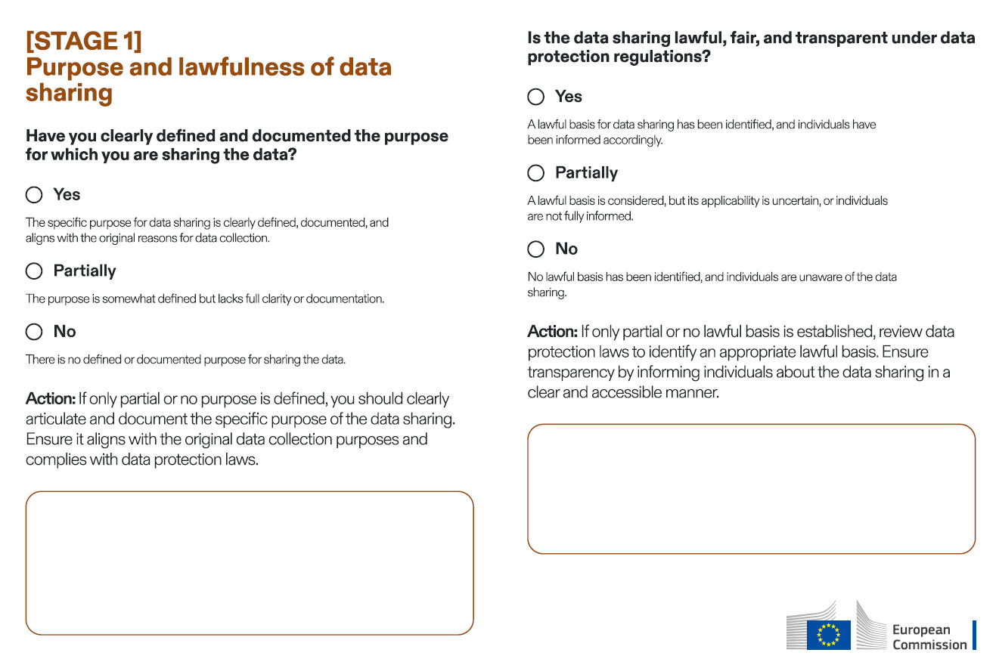

Example

Partially

The organisation intends to share employee data with a benefits provider but hasn't fully documented how this aligns with their data protection policies.

Example

Somewhat

User data is shared with third parties for marketing without any lawful basis or customer awareness, breaching GDPR requirements.

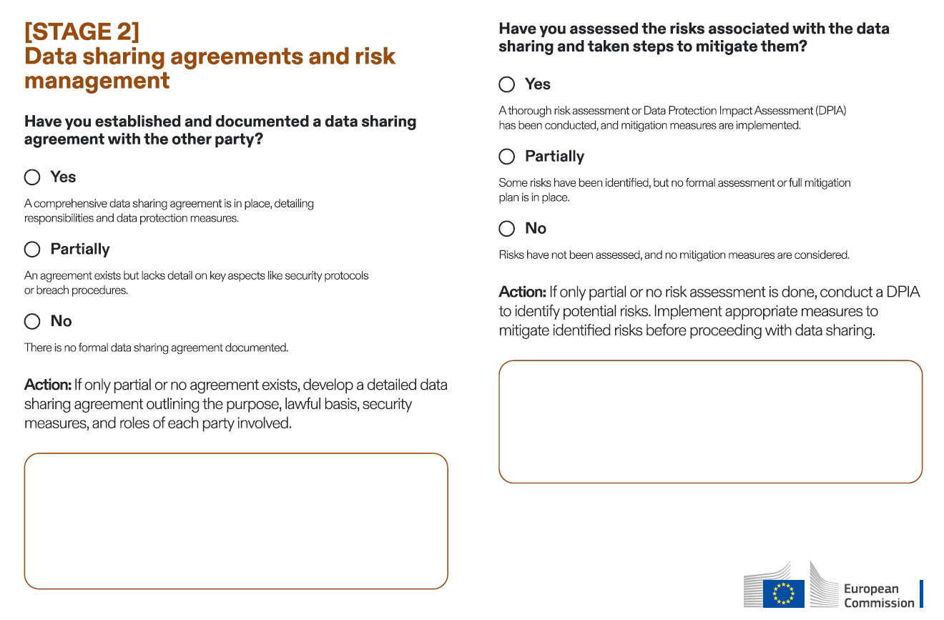

Example

Partially

Sensitive health data is shared without evaluating the risk of unauthorised access, leaving personal information vulnerable.

Example

Partially

An informal understanding is in place, but it doesn't specify how data will be securely transferred or who is responsible in case of a data breach.

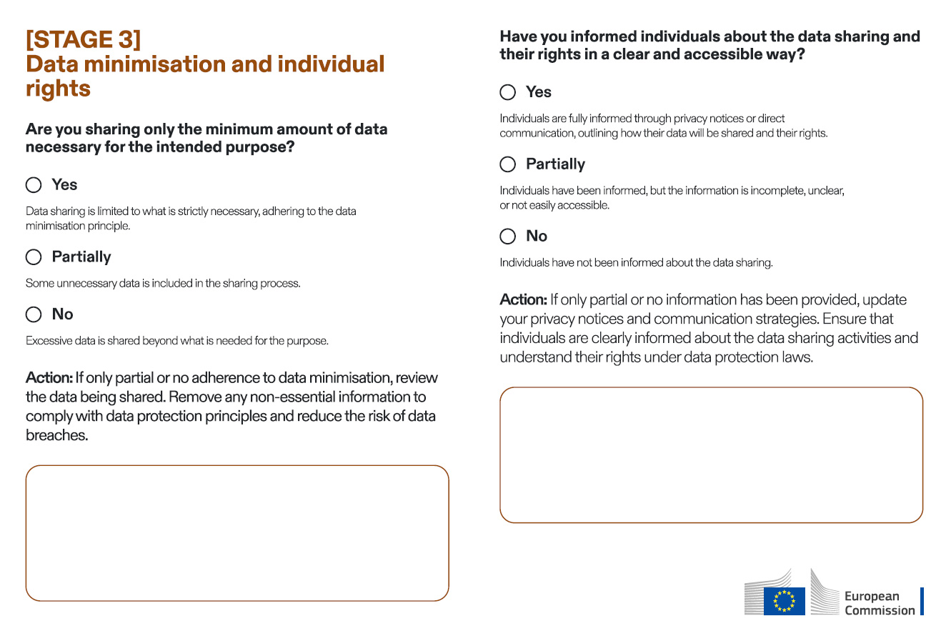

Example

Partially

Employees are unaware that their personal data is being shared with external trainin

Example

Partially

A government agency shares full citizen profiles with a municipal office

when only contact details are needed, resulting in unnecessary data

sharing.