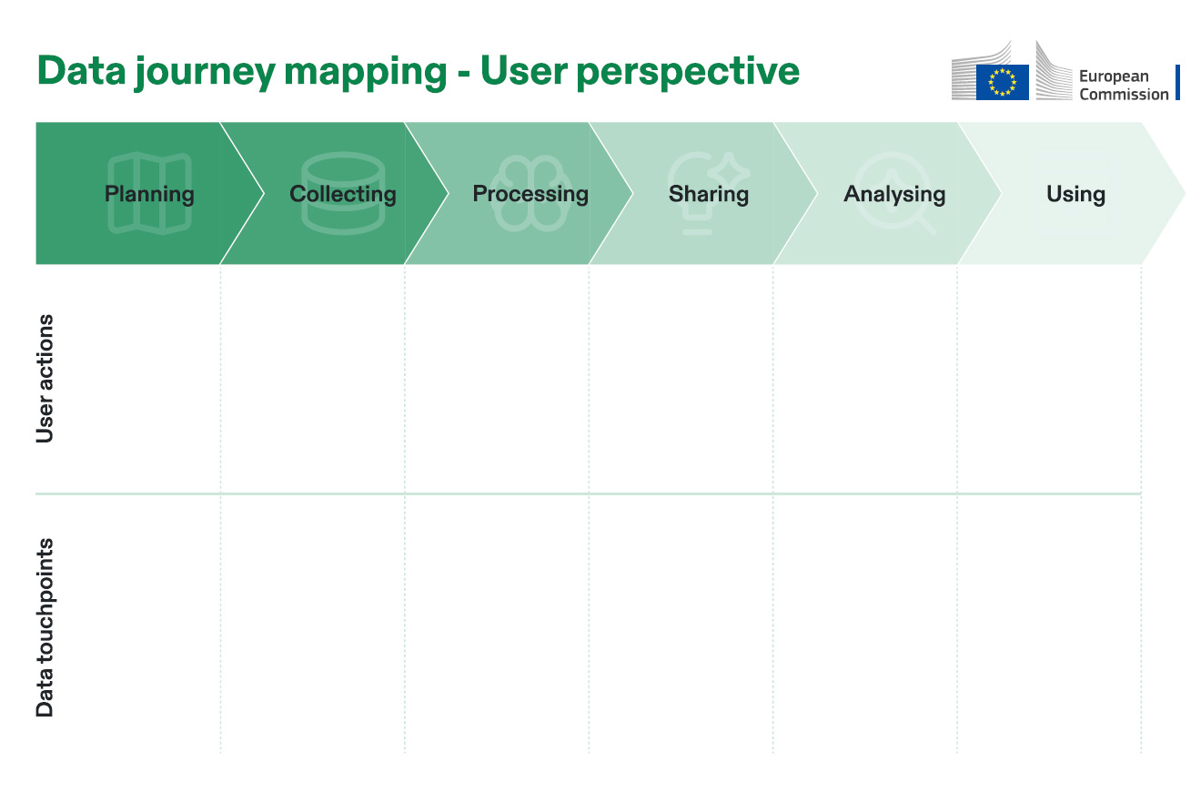

xxxxxxx

xxxxxxx

xxxxxxx

xxxxxxx

xxxxxxx

xxxxxxx

xxxxxxx

xxxxxxx

xxxxxxx

xxxxxxx