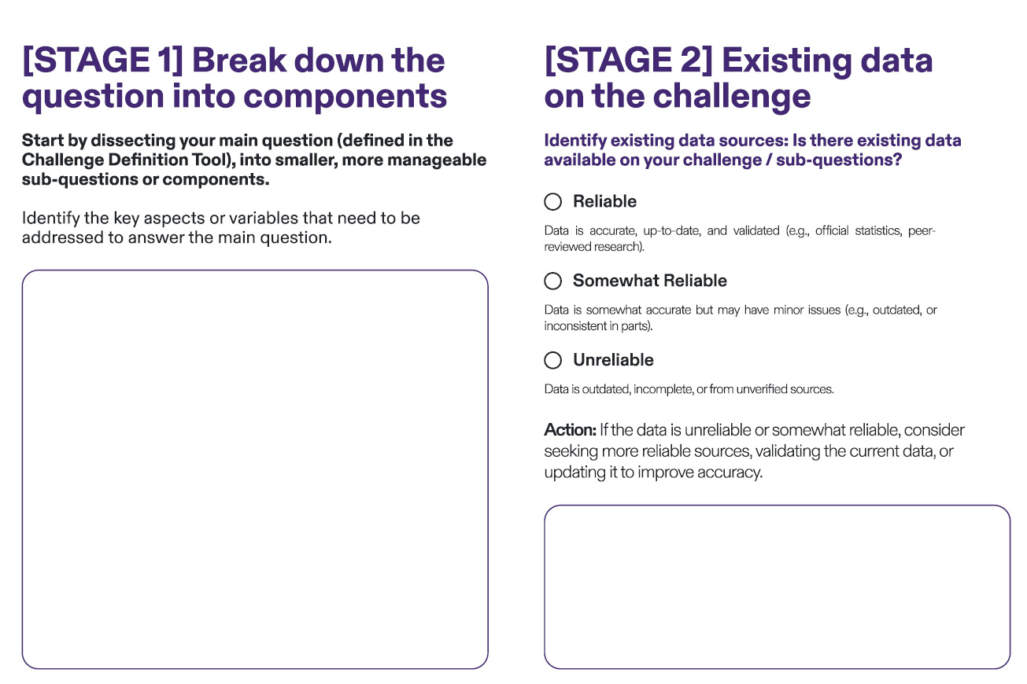

Guideline: At this stage, focus on discovering inconsistencies or omissions in how data is gathered across different agencies. For example, some agencies may collect data at varying frequencies (e.g., quarterly vs. annually) or use different definitions for similar metrics, such as “service utilisation” or “customer satisfaction.” These inconsistencies create challenges for aggregating data at a national level or comparing across agencies, limiting its utility for strategic planning.

Example

Somewhat Reliable

Data is somewhat accurate but may have minor issues (e.g., outdated or inconsistent in parts). Some data, like Eurostat and OECD datasets, are reliable but might not fully capture the nuances of the adoption across all stakeholders, leading to possible reliability issues

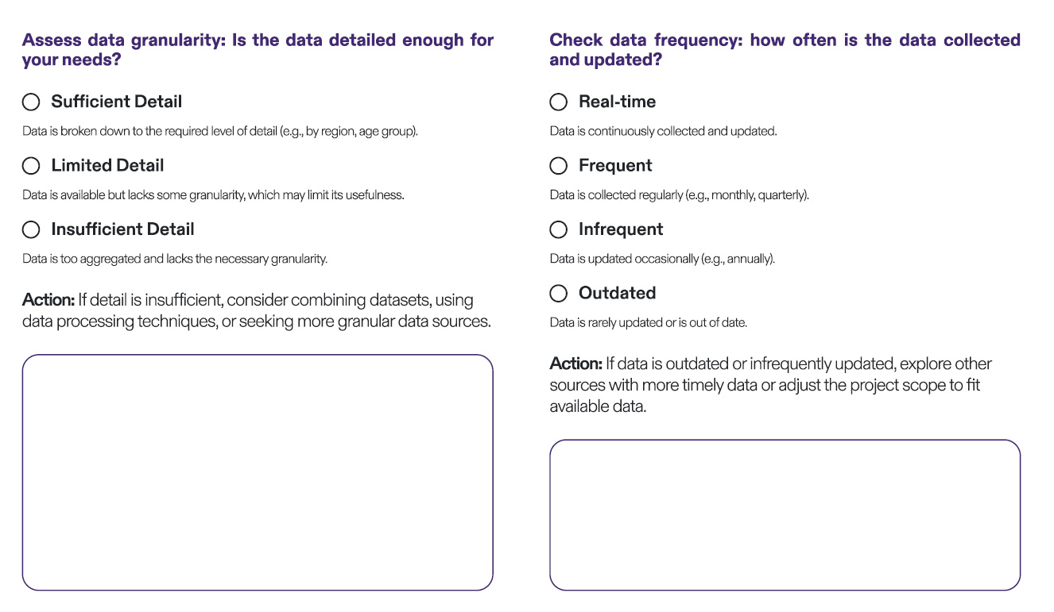

Example

Real-time

Data related to my project might be collected and updated in real-time

as part of other ongoing initiatives, but the frequency of updates might

vary across different stakeholders.

Example

Limited Detail

While data exists on different EU sources, it may lack specific

granularity related to the detailed implementation stages of my project,

such as the level of interoperability one needs to achieve at local/

regional levels within the scope of my project.

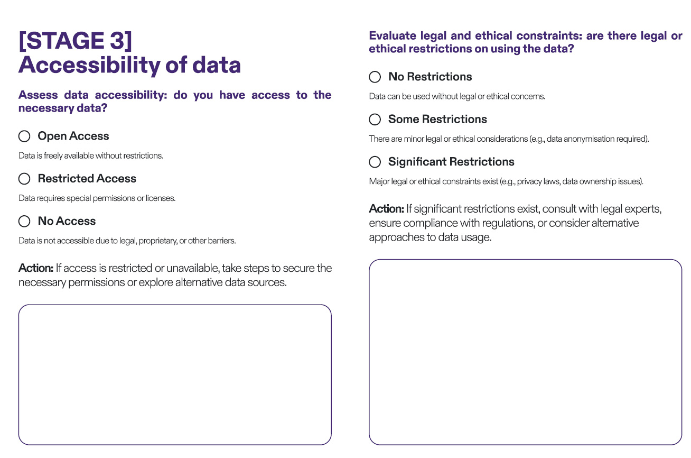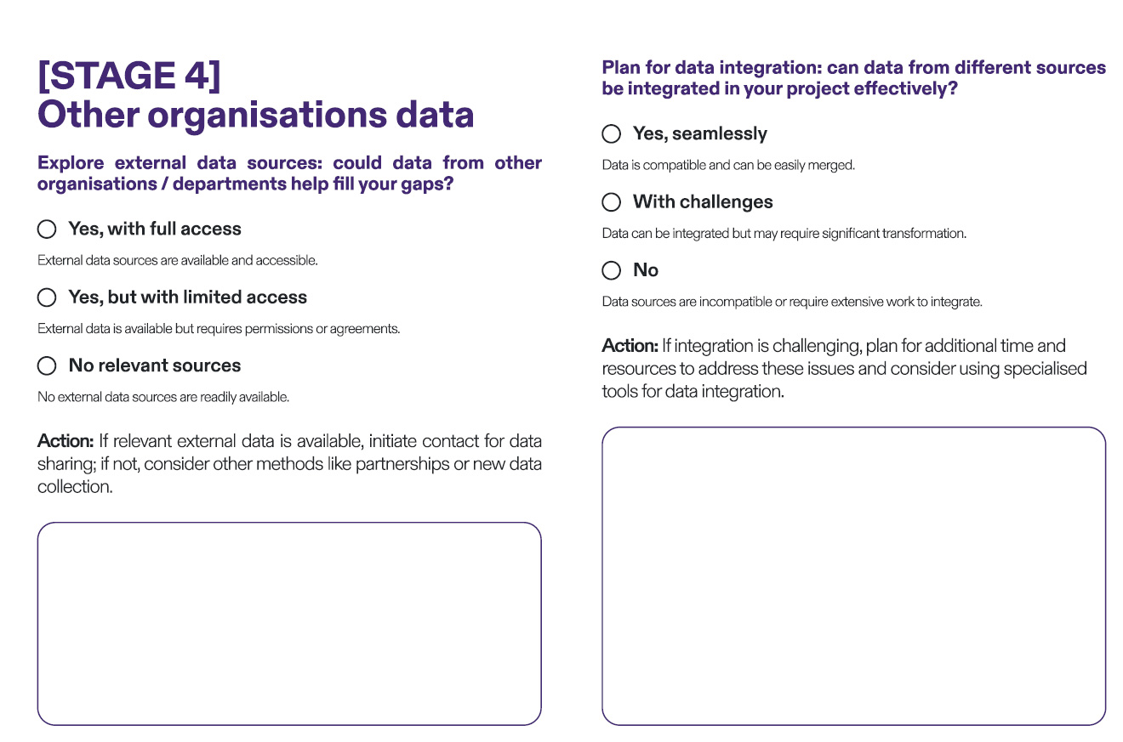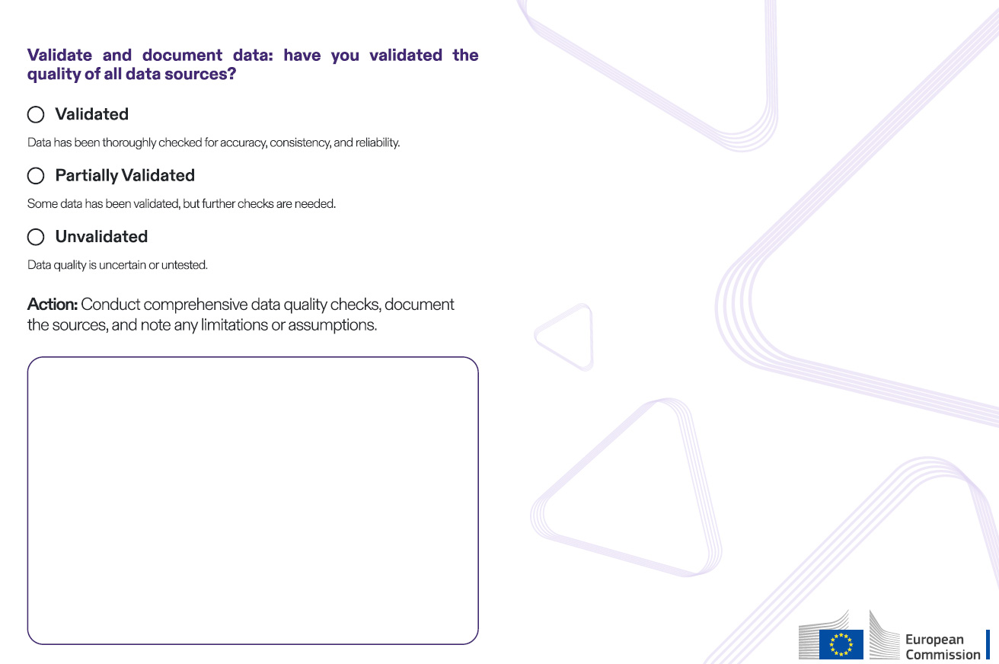

Example

Some restrictions

There are likely some legal constraints related to privacy and data

protection that must be considered when using the data across

different different stakeholders.

Example

Open Access

Much of the data related to my project implementation, especially from

EU institutions like Eurostat, is openly accessible for public use.

Example

Yes, with full access

Data from organisations like the World Health Organization (WHO) or

private data sources could supplement the data for a more

comprehensive view and adoption of my project.

Example

With challenges

Integrating data from organisations with varying levels of digital

infrastructure and standards can be challenging, requiring significant

data transformation.

Example

Partially validated

While some data, particularly from well-known sources, may be

validated, data from newer or less consistent sources might require

additional validation to ensure reliability.