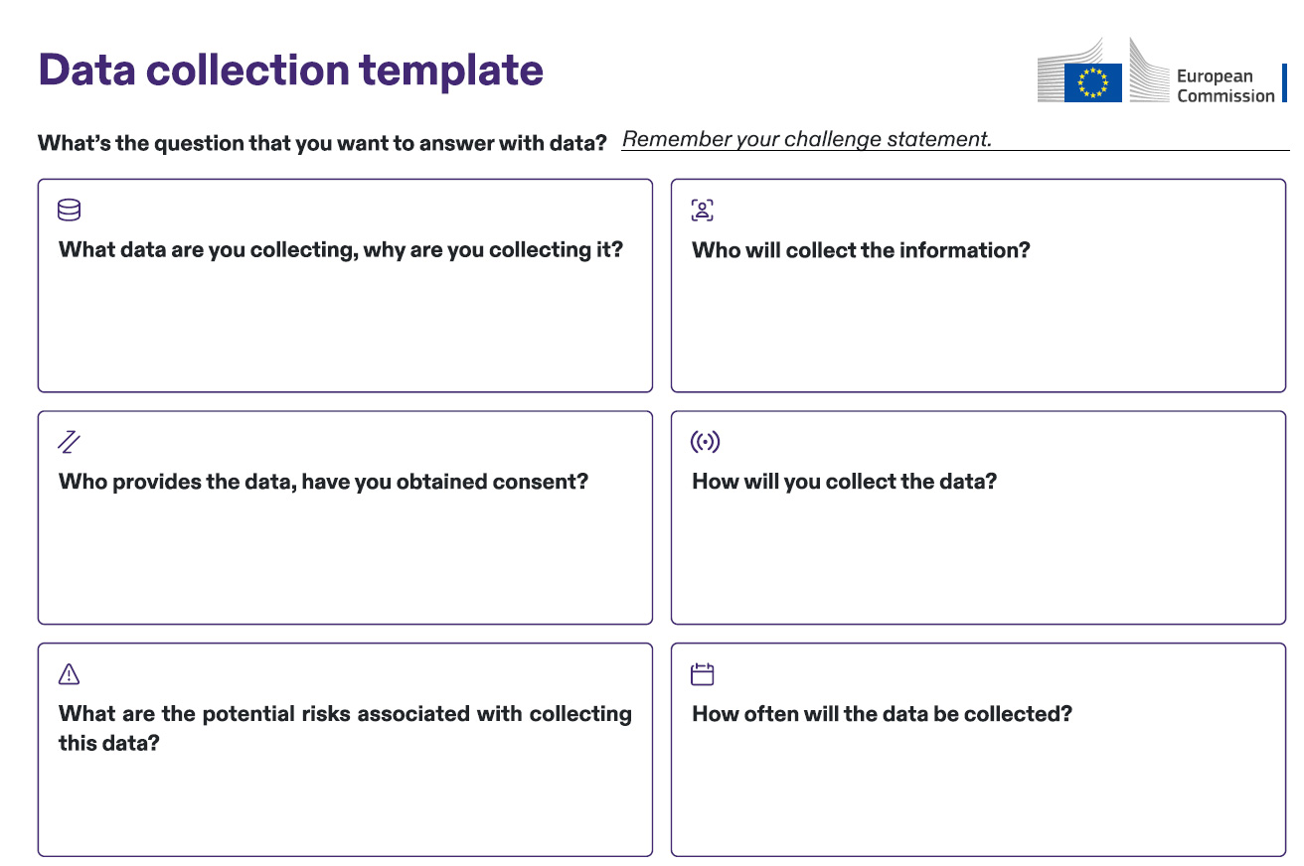

Set a timeline for your data collection. Will the data be collected once, periodically, or continuously? Clearly define the frequency to ensure consistency and relevance to your project.

Describe the method you will use to collect the data (e.g., surveys, interviews, sensors, or databases). Make sure the method aligns with your project goals and is appropriate for the type of data being gathered.

Assign responsibility for data collection. Determine which team member or group is responsible for collecting the data, ensuring accountability and clarity in the process. Utilise the RACI Matrix and Data Team Creation tools to support.

Identify any risks involved in data collection, such as privacy concerns, data security issues, or risks to the data providers. Plan how to mitigate these risks to ensure a secure and ethical data collection process.

Identify the individuals or groups who will be providing the data. Ensure you have their consent, especially if the data is personal or sensitive, to comply with ethical and legal requirements. Consent should be specific to the purpose of your project.

Specify the exact data you plan to collect and explain why this data is relevant to your project question. Be sure that every data point contributes to answering your question, and avoid unnecessary or irrelevant data to streamline your process.