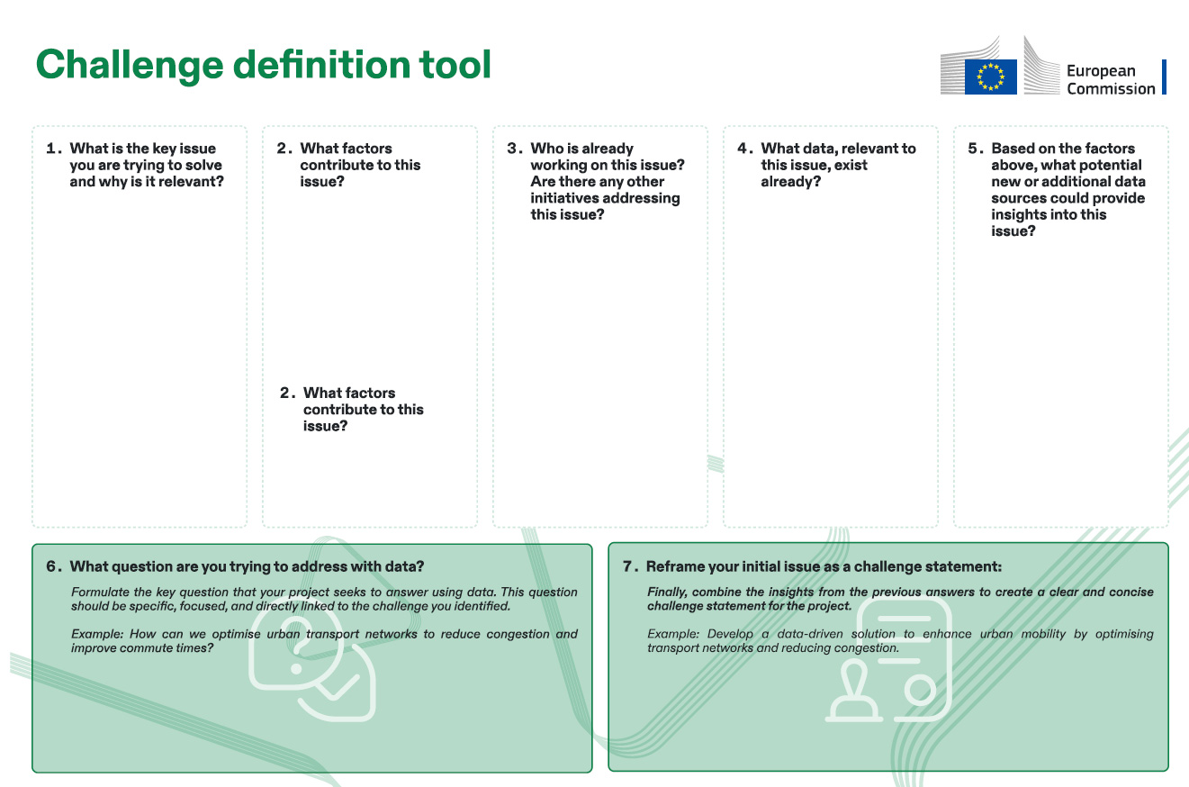

**7. Reframe your initial issue as a challenge statement:**

Finally, combine the insights from the previous answers to create a clear and concise challenge statement for the project.

Example: Develop a data-driven solution to enhance urban mobility by optimising transport networks and reducing congestion.

**6. What question are you trying to address with data?**

Formulate the key question that your project seeks to answer using data. This question should be specific, focused, and directly linked to the challenge you identified.

Example: How can we optimise urban transport networks to reduce congestion and improve commute times?

xxxWRITExxx

Suggest new or additional data sources that could offer further insights into the issue.

Example: Real-time GPS data from vehicles, mobile app data on commuter preferences, environmental pollution levels.

Identify existing data sources that are relevant to the issue.

Example: Traffic flow statistics, public transport usage data, road network maps.

Identify any existing efforts or initiatives, internal or extrernal, that are addressing the same issue.

Example: City council transport departments, local cycling advocacy groups, public transportation authorities.

Identify any existing efforts or initiatives, internal or external, that are addressing the same issue.

Example: City council transport departments, local cycling advocacy groups, public transport authorities.

Clearly define the primary Identify and describe the issue you aim to address contextual factors that and explain its significance contribute to the issue. to your organisation or stakeholders.

Example: Overreliance on private vehicles, limited Example: Inefficient urban public transport options, mobility causing congestion inadequate cycling and longer commute times. infrastructure.